[ Lifeshine]

A Major project submitted for the partial fulfillment of the requirements for the degree of

BACHELOR OF COMPUTER APPLICATION

**Submitted By**

Sudipta Halder

Roll No.: 15201218018 Session: 2018-2021

Registration. No.: 181521010101 of 2018-19

**Under The Supervision Of**

Mr. Subhendu Saha

Asst. Professor

Department Of BCA

Techno India (Hooghly – Campus)



Techno India (Hooghly – Campus)

Dharampur, G.T. Road, Near Khadina More

Chinsurah, Hooghly-712101

Website: [www.technoindiahooghly.org](http://www.technoindiahooghly.org), Email: [info@technoindiahooghly.org](mailto:info@technoindiahooghly.org)



***Certificate***

*This is to certify that the project entitled* ***“LifeShine.com”*** *submitted by* ***Sudipta Halder****, University Roll No: 15201218018 and Registration No.: 181521010101 of 2018-19 as Assigned Project (major) for the partial fulfillment of degree of Bachelor of Computer Application is worth of acceptance.*

**(Mr./Mrs. xxxxxxxxxxxxx) (Mr. Subrata Saha)**

Assistant Professor Head of the Department, BCA

Techno India (Hooghly – Campus)

**ACKNOWLEDGEMENT**

It is our pleasure to be indebted to various people, who directly or indirectly contributed in the development of this work and who influenced our thinking and acts during the course of study.

We express sincere gratitude to **Dr. Mrinal Kanti Chakrabarty** worthy **Principal** for providing us an opportunity to undergo this project at **Techno India (Hooghly-Campus).**

We are also thankful to Subhendu Saha for his support, cooperation, and motivation provided to us during the training for constant inspiration, presence and blessings.

Lastly, we would like to thank the almighty and our parents for their moral support and our friends with whom we shared our day-to-day experience and received lots of suggestions that improved our quality of work.

**Sudipta Halder**

**Subhankar Bera**

5th

JULY

2021



DOCUMENTATION

LifeShine.com

**DEVELOPED BY**

SUDIPTA HALDER ROLL NO – 15201218018

SUBHANKAR BERA ROLL NO – 15201218021

CONTENT

Introduction

|  |  |  |
| --- | --- | --- |
|  |  |  |
| 2. | Abstract |  |
| 3. | Objective and scope of the project. |  |
| 4. | Theoretical Background. |  |
| 5. | Definition of Problem. |  |
| 6. | System analysis and Design via user requirements. |  |
| 7. | Feasibility Study. |  |
|  | 7.1.Technical. |  |
|  | 7.2.Economical. |  |
|  | 7.3.Operational. |  |
|  | 7.4.Social. |  |
|  | 7.5.Legal. |  |
| 8. | System Planning. |  |
|  | 8.1.PertChart. |  |
| 9. | Methodology. |  |
|  | 9.1.Development Platform. |  |
|  | 9.1.1.HardwareDetails. |  |
|  | 9.1.2.SoftwareDetails. |  |
| 10. | System Maintenance and Evaluation. |  |
| 11. | Cost and Benefit Analysis. |  |
| 12. | Table Description. |  |
|  | 12.1TableswithAttributesDetails. |  |
| 13. | Life-Cycle of the project–ERD,DFD. |  |
|  | 13.1.ERD. |  |
|  | 13.2.DFD. |  |
|  | 13.3.ActivityDiagram. |  |
|  | 13.4.UseCaseDiagram. |  |
| 14. | Input-Output Screenshots. |  |
| 15. | Methodology used for testing. |  |
| 16 | Conclusion |  |
| 17. | Reference. |  |
|  | 17.1.Bibliography. |  |

### Introduction

In this covid-19 pandemic situation people feel uncomfortable and insecure for going crowed markets. Now a days we all habituated with internet and mobile phone or any other devices So, E-shopping is a best way to save a lot of times, So, in this project, we are going to build such an e-commerce web application where we can help people by delivering medicines and grocery. Naturally online stores are available 24hrs. So, our system is also available for 24 hours, Customer can buy Medicine and Grocery anytime as their requirement. Our Web Application designed especially for consumers, an online medicine and Grocery ordering and delivery system is ideal for those who are looking to order pharmacy products online to get them delivered at their doorstep. This process can be done through just a few simple steps:

a. User registration

b. Select the item Medicine or Grocery.

c. Add to cart the items what you need.

d. Selecting the mode of payment

e. Placing the order.

Abstract

Now a days people feel uncomfortable and time consuming for going crowed markets. So, E-shopping is a boon as it saves a lot of times. So, in this project, we are going to build such an e-commerce web application for order Grocery and Medicine.

Naturally online stores are available 24hrs. So, our system is also workable for 24 hours, can buy grocery, medicines anytime of their choices. And they also can add to cart of their different choice future they also can continue their shopping from cart.

### Objective and Scope

#### Objective of Online Grocery and Medicine Order System

The Online grocery and medicine booking system aims to deliver all grocery and medicines to timely and safely.

#### What are the facilities provided by Online Grocery and Medicine Order System ?

***Any where any time Access:-***

Citizen can order their needed products through our LifeShine. Our system provides latest information and fast delivery.

### Theoretical Background

* Why PHP?

Thesoftwaredevelopmentindustryhassustainedanunrelentinggrowthsinceitsinitiation and now in this age of cut-throat competition among web developing firms,sustainingtheusabilityofasingleapplicationdevelopinglanguagehadbecomeaneasier said than done. The market is experiencing an inundation of newer technologiesandprogramminglanguages.Ifonelooksfromthisperspective,thesurvivalandp opularityofHypertextPreprocessor(PHP), isa matterworth lookinginto.

PHPiswidelyusedfordevelopingwebsites duetocertainadvantages itoffers.

Gone are the days when static websites were used where a web page exhibited fixedbrochure-style data that could be edited only by the webmaster. But PHP could offerdynamic websites in which a user could access content from a database through anHTMLpagethatisgeneratedinrealtime.SoPHPcandevelopsitesthatmeettherequirement s of largebusiness establishments.

Complexity in developing an application with PHP is comparatively less because it doesnot need a framework to develop an application and the required codes is also less innumber.Thatiswhyitismoreuser-friendlythanASP.NET,C++orPython.Thisapplication isdevelopedoffsiteandthen itis embeddedinHTMLpage.

PHP has high integrative power too. It is user friendly with most servers and windows.OperatingsystemslikeWindows,Linux,MACarefinewithPHP.Alsoanumberofdata baseslike Oracle,MySQLand MSAccesscan be well managedby PHP enabledwebsites.

Another reason behind such extensive utilization of PHP is its recent versions has madeithighlyobjectorientedanditsoutstandingspeedinLINUXservershelpsthewebmastert obuildcomplexwebapplications.Ithasbecomemoreacceptableparticularlyforthosewebpro grammerswhoprioritizeautomationoftheirsites.

Its cost effectiveness has made it beginners’ choicer, because on the one hand it is opensource language—anyone can obtain it from Internet for free and learn it irrespective of whatever background he hails from. It is so easy that even a web developing firm cantrain theirnewrecruitson thislanguage.

ndoubtedlyitisthefinancialandtechnicalreasonsthathavegivenPHPwebdevelopment a breakthrough in this hard time when there are myriads of professionalwho are quite at home with programming languages but PHP has not yet finished its runsince as Internet and website has become a thriving industry and will remain so inforeseeablefuture.

* WhyMySQLDatabase?

MYSQLisoneofthetopdatabasesavailableinthemarket.MYSQLisarelationaldatabase with many advanced features and options. Over time, MYSQL has proved itselfto be a fast, reliable and cost effective competitor to the other more expensive databaseslike MS SQL Server and Oracle.

Here are a few of the advantages of using MYSQL indatabasedevelopment.

***Open Source***

MYSQL is an open source database system which means that anyone can use it for free.Developers can amend its code to suit their requirements which means that MYSQL ishighly customizable as well. Another edge of using MYSQL over other database systemsis that;itisavailablewidelyinthemarketwithnoownership cost.

***FastDevelopment***

Alotofpeoplearoundtheglobearecontinuouslydevelopingnewmodulesforintegration with MYSQL. This means that it has a wider and faster development circle.Patches, upgrades and fixes are developed fast and become available in forums, blogsanddevelopersitesontheinternet.

***BetterforSmallBusinesses***

This relational database system is free so it reduces the cost of overall database solutionforsmallbusinessesandcompanies.Thisdatabaseisrelativelyeasytolearnandopera te, so operational cost is reduced substantially which is again an important factorinclassifying MYSQL as an applicableandpracticaltoolforsmallbusinesses.

***Security***

MYSQL as a relational database is secure as all access passwords are stored in an encrypted format restricting any unauthorized access to the system. It also encrypts the transactions so eavesdroppers and data harvest tools cannot replicate or regenerate the database transactions once they are processed.

***Connectivity***

MYSQL clients can access this relational databasethrough standard TCP/IP sockets,named pipes, UNIX sockets and many more. Standard ODBC 2.5 and above functions andcommands arealsosupportedinMYSQL.

In short, MYSQL is a free and favored relational database system which is serving thewebandapplicationdevelopmentcommunities.

### DefinitionofProblem

A software development process consists of various phases, each phase ending with adefined output. The phases are performed in an order specified by the process modelwhichisfollowedbythedeveloper.Problemdefinitionandsoftwarerequirementspecif ication is an important phase of development process as it helps in understandingand clearly stating the problem that is to be solved. Understanding the requirements ofthe system is a major task as it emphasize in what is needed of the system but not howthesystemit’sachieveditsgoal.

Problemdefinitionandrequirementanalysisspecificationdemandstheanalystdevelopsthro ughunderstandingoftheexistingsystem,partsofwhichhastobeautomated.Thisrequiresinte ractionwiththeclientendusersaswellasstudyingexisting manuals and procedures. Understanding the properties of the system that doesnot exist is more difficult and requires load of creative thinking as well as good problemdefinition. It is the job of the analyst to make aware the client of new probabilities withtheautomatedsystem,thushelping,bothtospecifytherequirements.

Problem definition is vital step is software specification that gives a clear overview ofthe system. SRS is to be documented in some specific language e.g. English regular’sexpression, tables or a combination of all of these. The SRS document must specify allfunctional and performance requirements, the formats of input and outputs of all designconstraintsthat exist duetopolitical,economic,environmentaland securityreasons.

In sort to understand the objectives of the software to be built, the analyst must definetheproblemandunderstandtheinformationdomainforthesoftware,aswellas,require d function, behavior, performance and interface. Requirement and documentedandreviewedwithuser.

***ThefollowingactivitiesdefinetheproblemoftheRegistrationPro cess:-***

When a visitor wants to register to the site must take in all the necessary information tomaintain a unique database for the user. The user id chosen by him should be unique. Hemust also provide a password for the user the security of his account. A secret questionand answer is also maintained for generating a password in case he has forgot his oldpassword.

The following activities define the process of navigation and information availableonthesite:

This module is used when a registered user login their account go to home page andgather informationabouthim. Heredependingonthefunctionwe have to proceedfurther.

System Analysisand Design via user Requirements

Thesoftwarerequirementsandspecificationisproducedattheculminationoftheanalysis task. The function and performance allocated to software as part of systemengineering are refined by establishing a complete description, a detailed functionaldescription,arepresentationofsystembehavior,andindicationofperformancere quirementsanddesignconstraints,appropriatevalidationcriteriaandotherinformation requirements.

The introduction of software requirement specification states the goals and objective ofthesoftware,describeitincontextofthecomputerbasedsystem.Actuallytheinformation maybenothingmorethanthesoftwarescopeplanningdocument.

***Hereinthisprojecttheintroductionisdescribedasfollows:-***

* Theinformationdescriptionprovidesadetaileddescriptionoftheproblemthatthesoftware mustsolve.
* Informationcontent,flow,and structurearedocumented.
* Hardwareandsoftwareinterfacesaredescribedforexternalsystemelementsandinternalsof twarefunctions.

Adescriptionof each functionrequiredto solvethe problem is presentinfunctiondescription.Aprocessingnarrativeisprovided.

In many cases of software requirement specification may be accompanied an executableprototype or a preliminary user’s manual. The preliminary user’s manual presents thesoftwaremanualasblackbox.Thatisheademphasisisplacedonuserinputandresultant output. The manual can serve valuable tool for uncovering problems at thehuman

machineinterface.

### FeasibilityStudy

Afeasibilitystudiesmaingoalistoassesstheeconomicviabilityoftheproposedbusiness.The

feasibility study needsto answer the question: “Doestheidea makeeconomicsense?”Thestudyshouldprovideathoroughanalysisofthebusinessopportun ity, including a look at all the possible roadblocks that may stand in the way ofthe cooperative’s success.The outcome of the feasibility study will indicate whether ornot to proceed with the proposed venture.If the results of the feasibility study arepositive,thenthecooperativecan proceedtodevelopabusinessplan.

If the results show that the project is not a sound business idea, then the project shouldnot be pursued.Although it is difficult to accept a feasibility study that shows theseresults, it is much better to find this out sooner rather than later, when more time andmoneywouldhavebeeninvestedandlost.

WhyFeasibilityStudyRequired?

Afeasibilitystudyshouldexaminethreemainareas:

* Marketissues
* Technicalandorganizationalrequirements
* Financialoverview

***MARKETISSUES***

Theprimaryareathatthefeasibilitystudyneedstoaddressispotentialmarketopportunities for the cooperative.If an adequate level of demand does not exist for theprojectandtheusersareprefertoofflinesubmissionthenourmotiveis useless.

***Questions that need to be answered in this area of the feasibility studyinclude:***

WhattypeofprojectistheOnlinePassportGenerationSystem?

What areitsprimaryfeatures?What arethepossibletarget marketsfor this project?

Whatdemographiccharacteristicsdotheypossess?Howlargearethesemarkets?Where aretheylocated?Is themarketexpectedtogrow inthefuture?

Will the NGC becompetingin amature growth industry?

***TECHNICALFEASIBLITY***

Thisisconcernedwithspecifyingequipment’sandsoftware

thatwillsuccessfullys

atisfytheuserrequirements.Theproposed systemistechnicallyfeasiblebecause

* It iscapabletoproduceoutputwithinaveryshort time.
* Responsetimeissatisfactoryeventhenumberofuserislarge.
* It’sabletoprocessacertainvolumeoftransactionat aparticularspeed.
* Itfacilitatestocommunicatedatatodistantlocations.

***ECONOMICFEASIBLITY***

Economicanalysisisthemostfrequentlyusedmethodforevaluatingtheeffectivenessof a proposed system. It is commonly known as cost benefit analysis. The procedure thebenefits and saving that are expected from a proposed system. It is economically feasiblebecause of thefollowingreason:

* Equipmentacquisitioncostfortheproposed systemisminimal.
* Equipmentoperationalandmaintenancecostiscomparativelylessthanotheralternatives.
* Personneltrainingcost isminimal.
* S/Wacquisitionanddevelopmentcostiscomparativelylessthanotheralternatives.

***OPERATIONALFEASIBLITY***

* Thesystemis easytouse.
* Thesystemisfullyuserfriendlysotheotheruserneednottoremembertheinvocation of commandwithvariousoptions tousethesystem.
* Thejobwillbelesstedious.
* Theusertrainingrequiredveryshortcourseoftime.

***SOCIALFEASIBLITY***

* Itisalso adeterminationofwhetheraproposedprojectwillbeacceptabletothepeopleornot.
* Medicalwebsiteisexceptionally“UserFriendly”&hasbeenconfiguredwithinexperiencedco mputerusers inmind.

***LEGALFEASIBLITY***

Itisadeterminationofwhetheraproposedprojectinfringesonknownactsaswellasanypending registration.Websitehas notbeenanylegal hindrances

### SystemPlanning

***<***

PERTCHART

The Program(or Project)EvaluationandReview Technique, commonlyabbreviatedPERT, is a statistical tool, used in project management, that is designed to analyze andrepresent the tasks involved in completing a given project. First developed by the UnitedStatesNavy in the 1950s, itis commonly usedinconjunction with the critical pathmethod(CPM).

A PERT chart is a tool that facilitates decision making. The first draft of a PERT chart willnumber its events sequentially in 10s (10, 20, 30, etc.) to allow the later insertion ofadditional events. Two consecutive events in a PERT chart are linked by activities, whichareconventionallyrepresentedasarrows(seethediagramabove).Theeventsareprese nted in a logical sequence and no activity can commence until its immediatelypreceding event is completed. The planner decides which milestones should be PERTevents and also decides their “proper” sequence. A PERT chart may have multiple pageswith many sub-tasks. PERT is valuable to manage where multiple tasks are occurringsimultaneouslytoreduceredundancy.

***SomeadvantagesofPERTchartasfollows:***

* It forcestomanagertoplan.
* Itshows the interrelationships amongtasks inthe projectand, inparticularclearlyidentifies.Thecostofthehardwareandsoftwarefortheclassofapplication beingconsidered.
* The benefitsintheform ofreducedcostorfewercostlyerrors. The costisnothingchangesthecriticalpathallowsastheopportunitytoconsideralternativeappro achtocopepotentialproblem.
* It expresses all possible parallelism in the activities and thus helps in allocatingresources.
* Itallowsschedulingandsimulationsofalternativeschedule.
* It exposes all possible parallelism in the activities and thus helps in allocatingrecourses.
* Itallowsschedulingandsimulationsofalternativeschedules.

Despite this advantages PERT is just a tool and its use doesn’t automatically guaranteethe success of the project. The manager has much latitude in how PERT is used. Manyvariations of PERT charts are a possible. For big project a PERT chart may containshundredsofnodesandspanmanypages.Theavailabilityofcomputersupportisessen tial for managing large PERT networks. Many such tools are available for mostcomputers.Theysupportbothoftheinitialpreparationofthenetworkandthecontinuou s updating of the chart during the project. These tools make it possible toexperimentwithdifferentschedulingoptionsinordertocreatedifferentcriticalpaths.

GiftcanbederiverautomaticallyfromPERTcharts.PERTchartsarebetterformonitoringtheti melyprogressactivities.Ifreschedulingbecomesnecessaryforexample because of missed milestone, we may want to go back and draw new GNATTchartforpreparingtheutilizationofresources.Againsciencetherevisionofthesechart s areoftennecessarycomputersupport isoften essential.

Anydelayinanyactivityinthispathwillcauseadelayintheentireproject.Themanagerwillclea rlywanttomonitortheseactivities.

Asfortheproject isconcernedthetotalproject isdonewithinthreemonths.

|  |  |  |  |
| --- | --- | --- | --- |
| **Activity** | **Activity Name** | **Duration (Hour)** | **Predecessor** |
| A | Project  planning | 30 | - |
| B | Designing | 90 | A |
| C | Coding | 162 | B |
| D | Testing | 25 | C |
| E | WritingManual | 33 | D,E |
| F | Implementation | 17 | D |

Now wecalculatetheCriticalPath

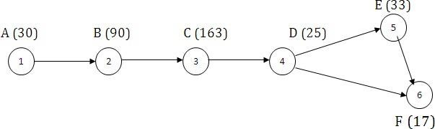

CriticalPath=30+90+163+25+33+17=358Hours.

### Methodology

DevelopmentPlatform

*CLIENTSIDEANDSERVERSIDEHARDWAREINTERFACEDETAILS*

|  |  |
| --- | --- |
| ClientSide | |
| **Processor** | IntelPentiumIV2.0GHzandabove |
| **RAM** | 128MBandabove |
| **Diskspace** | 1GB andabove |
| **Others** | StandardInputOutput(Mouseand Keyboard) |

|  |  |
| --- | --- |
| Server Side | |
| **Processor** | IntelPentiumIV2.0GHzandabove |
| **RAM** | 2GB andabove |
| **Diskspace** | 15GBandabove |
| **Others** | StandardInputOutput(MouseandK  eyboard) |

*CLIENTSIDEANDSERVERSIDESOFTWAREINTERFACEDETAILS*

|  |
| --- |
| ClientSide |
| **Web Browser** InternetExplorer6.0,Firefox6.0,Google Chrome(above) |
| **OperatingSystem** Windows10/ Windows7/WindowsXp |

|  |  |
| --- | --- |
| ServerSide | |
| **WebBrowser** | InternetExplorer6.0,Firefox6.0,Google Chrome(above) |
| **OperatingSystem** | Windows10/ Windows7/WindowsXp |
| **Framework** | PHPFramework |
| **Database** | MySQL |

### RolesofToolsinDevelopment

#### AdobeDreamweaverCS6:

AdobeDreamweaverCS6isawebdevelopmentapplicationoriginallycreatedbyAllierSystems whichwasacquired in1998byMacromedia&nowownedbyAdobesystems.

DreamWeaverisavailable forbothMac&WindowsOperatingSystems.Recent versionshave incorporated Support for web technologies such as CSS, JavaScript and variousframeworks including ASP.NET,ColdFusion,JavaServerpages &PHP.

Features:

As a WYSEWYC Presto-based editor, Dream Weaver can hide the details of the pages.HTML code from the user making it possible for non-coders to create web pages & sites.One criticism of the approach is that it can produce HTML pages whose file size andamountofHTMLcodeislargerthanand optimallyhandcodedpagewouldbe,whichcancause web browsersto perform poorly. His can be particularly true as the applicationmakes it very easy to create table based layouts. In addition some website developershave criticized Dream weaver in the past for producing code that often does notcomplywith W3C standards, through recent versions have been more compliant . Dreamweaver8 performed poorly on Acid Test, development by web standards project. HoweverMacromedia has increased the support for CSS & other ways to lay out a page withouttables in later versions of applications with the ability to convert tables to layers viceversa.

Dreamweaver allows users to preview websites in many browsers, provided that isinstalled on their computer. It also has some site management tools, such as the abilityto find and replace lines of text or code by whatever parameters specified across theentire site, and a temptation feature for creating multiple pages with similar structures.Thebehaviors’planealsoenablesuseofbasicJavaScriptwithoutanycodingknowl edge.

Dreamweaver can also “Extensions”-small programs, which any developer can write.Extensionsprovideadded functionalityforthesoftwareforwhoeverwantstodownloadand install them.Dreamweaver is supported by a large community of extensionsavailable for (both commercial & free) most web developments tasks from simplerollovereffectstofull-featuredshoppingcarts.

Like other HTML editors, Dreamweaver edits files locally, and then uploads all editedfiles to the remote web server using FTP, SMTP, or web DAV. Dreamweaver CS4 nowsupports thesubversion(software) (SVN) versioncontrolsystem.

#### HTML(HyperTextMarkupLanguage)

HTML, an initialize of Hyper Text Markup Language, is the predominant markuplanguage for web pages. It provides a means to describe the structure of web basedinformation in a document-by denoting certain text as links, headings, and paragraph,listandsoon- andtosupplementthattextwithinteractiveformsembeddedimages,andother objects.HTML is written in the form of tags, surrounded by angle brackets. HTMLcan also describe to some degree the appearance and semantics of a document, and caninclude embedded scripting language code (such as JavaScript) which can affect thebehaviorof webbrowserandotherHTMLprocessors.

FilesandURLscontainingHTMLoftenhave.htmlor .htmfilenameextension.

#### JavaScript

JavaScript(sometimesabbreviatedJS) isascriptinglanguagecommonlyimplementedas part of a web browser in order to create enhanced user interfaces and dynamicwebsites.

JavaScriptisaprototype-basedscriptinglanguagethatisdynamic,weaklytypedandhasfirst- class functions. It uses syntax influenced by the language C. JavaScript copies manynames and naming conventions from Java, but the two languages are otherwiseunrelated and have very different semantics. The key design principles within JavaScriptare taken from the self and Scheme programming languages. It is a multi- paradigmlanguage,supportingobject- oriented,imperative,andfunctionalprogrammingstyles.

Features:

JavaScriptisanembeddablescriptinglanguage,soitcanruninaBrowser,but itcanjustas well run on a Server. So when we use JavaScript for Error Handling it’s not need toround-trip fromserver.Soaccessisfastandsecure.

Windows-Apache-MySQL-PHP (XAMPP) With MySQLDatabase

***XAMPP ***

XAMPP is an installer for windows. It installs a complete XAMPP solution on your computer. XAMPP is for Windows-Apache-MySQL- PHP5. XAMPP automatically configures them to work together, when every one install them on your local drive.

Thesesoftware’sare installed:

* Apache2.2.11
* PHP5.3.0
* MySQL5.1.36

**XAMPP requires one of these systems to work:**

* Windows XP, NT,2000,2003,Vista,Windows 7.
* XAMPP is totally compatible with other server installation:
* The installation is compact. Thismeansallfilesarecopied inthesamedirectory.
* Theusualmy_inifileis called mywamp.ini,soit is uniquetoWAMP5.1.36.

### SystemMaintenanceandEvolution

Maintenance is necessary to evaluates & eliminate errors in the working system duringits working life & to tune the system to any variations in its working environments.Therearealwayssomeerrorsdetectedthatmustbe corrected. Oftensmall systemdeficiencies a found as a system is brought into operations and changes are made toremove them. Information system planners must always plan for resources availabilitytocarryoutthesemaintenancefunctions.

If a major change to a system is needed a new project may have to set up to carry it out.Thesenew projectwillthen proceedthrough allthe above lifecyclephases.

Thirtyyearsago,softwaremaintenancewascharacterizedasan“iceberg”.Themaintained for existing software can account for over 60% of all effort expended bydevelopmentorganizationandthepercentagecontinuetoriseasmoresoftwareisproduced

.

Therearefourtypesofdifferentmaintenanceactivities.Theyare:- Correctivemaintenance,Adaptivemaintenance,Perfectivemaintenance&Preventivemaint enance.

* ***CorrectiveMaintenance:-***

Corrective maintenance changessoftware to the current defects. For examplethe project is made for Guest house management system. If the user does not fillanyoftherespectivetextboxesthentheprojectwillgiveanerrorwhichrequests theusertofillthetxtboxes.

* ***AdaptiveMaintenance:-***

It results in modification of the software to accommodate changes to its externalenvironment.

* ***PerfectiveMaintenance:-***

PerfectiveMaintenanceextendsthesoftwarebeyonditsoriginalfunctionrequiremen ts.

* ***PreventiveMaintenance:-***

Preventive maintenance often called software re-engineering must be conductedto enable to serve the needs of its end users. In essence it makes to computeprograms & sothattheycanbeeasilycorrected,adopted& enhanced.

### CostandBenefitAnalysis

Whenaprojectisdevelopedcostsareincurredthroughitslifecycle.Benefitsarerealizedinthef ormofreducedoperationcosts,improvedcorporateimage,staffefficiencyorrevenues.

Cost and benefit analysis is a procedure that gives a picture of the various costs,benefits & rules associated with a system. The determination of costs & benefits entailsthefollowingsteps.

1. Costs&benefitspertainingtotheproject areidentified.
2. Thevariouscosts&benefitsarecategorizedforanalysis.
3. Anevaluationmethodisselected.
4. Theresultsofanalysisareinterpreted.

Costsare identifiedas tangible, intangible costs, directand indirectcosts, fixedandvariablecosts.

***CostEstimationoftheProject***

|  |  |  |  |  |
| --- | --- | --- | --- | --- |
| **Stage**  **ofProducti on** | **Duration (Hr)** | **PersonRe sponsible** | **Person**  **(Hr)(Rs.**  **)** | **Cost (Rs.)** |
| **ANALYSIS** | **30** | **2** | **22** | **660** |
| **DESIGNING** | **90** | **3** | **30** | **2700** |
| **CODING** | **162** | **3** | **35** | **5670** |
| **INTEGRATION &TESTING** | **25** | **1** | **19** | **475** |
| **WRITING MANUAL** | **33** | **2** | **15** | **495** |
| **TotalCostofTheProject** | | | | **Rs10000** |

### TableDescription

|  |  |  |
| --- | --- | --- |
| **TableName** | **Purpose** | **PrimaryKey** |
| admin | Administratordetails,SuperUserdetails | adminid |
| check | Checkthefreshusersubmitteddocumentsv erificationdetails | uname,fno |
| check_re | ChecktheRe- issueusersubmitteddocumentsverificationdetails | uname,fno |
| ct | Controltablecontrolstheappointmentdatetime | slno,date |
| feedback | Keeps the feedback according tosubmitting time | ---- |
| image | Stores the fresh user document in BLOBFormat | uname |
| mainimg | FinallyStoresthefresh/re- issueuserdocumentinBLOBFormat | uname |
| opassport | FinallyStoresthefresh/re-issueuserdata | uname |
| reimage | Storesthere-issueuserdocumentinBLOBFormat | uname |
| reissue | Storesthedataofthere-issueusers | uname |
| slot | Storestheappointmentscheduleofthefresh/re- issueusers | uname,fno |
| state | Stores the PGK Name along with address,statewise | id |
| users | Storesthelogindetailsofeveryusers | uname |
| user_details | Storesthedataofthefreshusers | uname |

TableswithAttributesDetails

|  |  |  |  |  |
| --- | --- | --- | --- | --- |
| **Field** | **Type** | **Null** | **Key type** | **FieldDescription** |
| **adminid** | varchar(16) | No | PRIMARY | Storesadminid |
| **pwd** | varchar(40) | No | ---- | Storesadmin Password |
| **fullname** | varchar(40) | No | ---- | Storesfullnameof ADMIN |

|  |  |  |  |  |
| --- | --- | --- | --- | --- |
| **Field** | **Type** | **Null** | **Keytype** | **FieldDescription** |
| **uname** | varchar(40) | No | PRIMARY | Storesusername |
| **fno** | int(16) | No | PRIMARY | Storesfilenumber |
| **adate** | date | No | ---- | Stores appointmentdate |
| **atime** | time | No | ---- | Stores theappointmentti me |
| **birth** | varchar(40) | No | ---- | Stores theconfirmation ofdocument of birthasverifiedor  not. |
| **addr** | varchar(40) | No | ---- | Stores theconfirmation ofdocument ofaddressproofas  verifiedornot. |
| **oth** | varchar(40) | No | ---- | Stores theconfirmation ofdocument of other(Nationalityp roof)asverified  or not. |
| **photo** | varchar(16) | No | ---- | Stores the path ofthe taken picturebycameradur ing  verification |
| **photoid** | varchar(50) | No | ---- | Photo ID of takenphotooftheus  er |

|  |  |  |  |  |
| --- | --- | --- | --- | --- |
| **Field** | **Type** | **Null** | **Key type** | **FieldDescription** |
| **uname** | varchar(40) | No | ---- | Stores the usernameofthefeedba ck  givenuser |
| **feedback** | varchar(500) | No | ---- | Storesthefeedback |
| **date_time** | bigint(15) | No | ---- | Storesthedate time of the  givenfeedback. |

|  |  |  |  |  |
| --- | --- | --- | --- | --- |
| **Field** | **Type** | **Null** | **Keytype** | **FieldDescription** |
| **uname** | varchar(50) | No | PRIMARY | Storestheusername ofthe user |
| **path** | mediumblob | No | ---- | Storesthefirst document in  BLOBFormat |
| **path2** | mediumblob | No | ---- | Storesthesecond document in  BLOBFormat |
| **path3** | mediumblob | No | ---- | Stores the thirddocumentinB LOB  Format |

LIFECYCLEOFTHEPROJECT– ERD,DFD

#### ENTITYRELATIONSHIPDIAGRAM

An Entity Relationship Diagram (ERD) is a network model that describes the stored datalayout of the system. ERD are used because the data structures and relationships in a systemmaybesocomplexthatonemaywanttohighlightthemandexaminethemindependentlyof the processing that takes places in the system. The ERD was originally proposed by PeterChen for the design of the relationaldatabase systems and has been extended by others.TheprimarypurposeoftheERDistorepresentthedataobjectsandtheirrelationships.

ImportanttermsinE-RModeling:-

***MappingCardinalities:***

MappingCardinalitiesExpressthenumberofentitiestowhichotherentitycanassociat ewitheachotherviaarelationshipset.Itcantakefollowingforms.

***Oneto One(1:1):-***

AninaassociatedwithatmostoneentityinBandanentityinBisassociatedwithatmosto neentityinA,whereAandBaretwodifferententitysets.

***OnetoMany(1: N):-***

AnentityinAisassociatedwithmanynumberofentitiesinB,AnentityinBhowever,canb eassociatedwithalmostoneentityinA.

***ManytoOne(N:1) :-***

AnentityinAisassociatedwithalmostoneentityinB.AnentityinB,howevercanbeassoc iatedwithanynumberofentitiesinA.

***ManytoMany(M:N):-***

AnentityinAisassociatedwithanynumber ofentitiesinB,andanentityinBisassociatedwithanynumberofentitiesinA.

#### DATAFLOWDIAGRAM

Data models have been used in the project to realize the problem domain and solutionprocedures visually. Data flow diagram techniques have been depicted to identify thesolution processandthewaytomaterializeit.

Data flow diagram that demonstrates the flow of various data and information throughthe system. It also enables the identification of the processes that converts one set ofdata to another set of information. DFD is helpful to identify the entities external to thesystemandthedatastoresthatshouldbeincludedin theproject.

DataFlowDiagram(DFD)Symbols:

Rectangle represents the source or destination ofsystemdataalsocalledan externalentity.

ArrowrepresentsDataflow.

Circleorbobblerepresentsaprocessthattransformd atafromonefromtoanotherbyperformingsometask withthedatacallprocess.

An open rectangle is data store. Data store is placewheredataisheldtemporarilyfromonetransac tiontothenextorit storedpermanently.

### DATA FLOW DIAGRAM

**DATA FLOW DIAGRAM LEVEL 0**

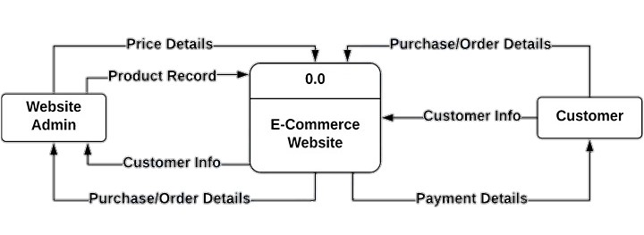

**DATA FLOW DIAGRAM LEVEL 1**

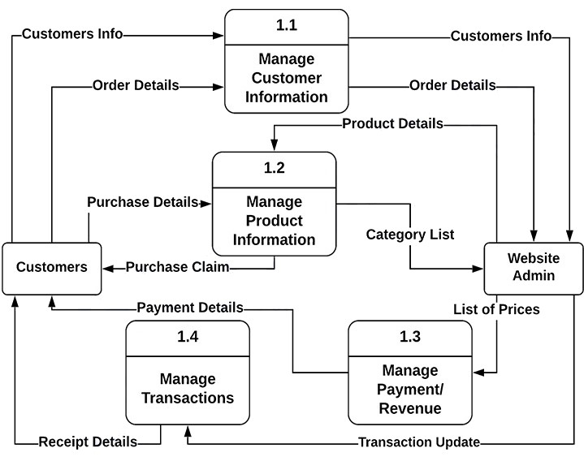

**DATA FLOW DIAGRAM LEVEL 2**

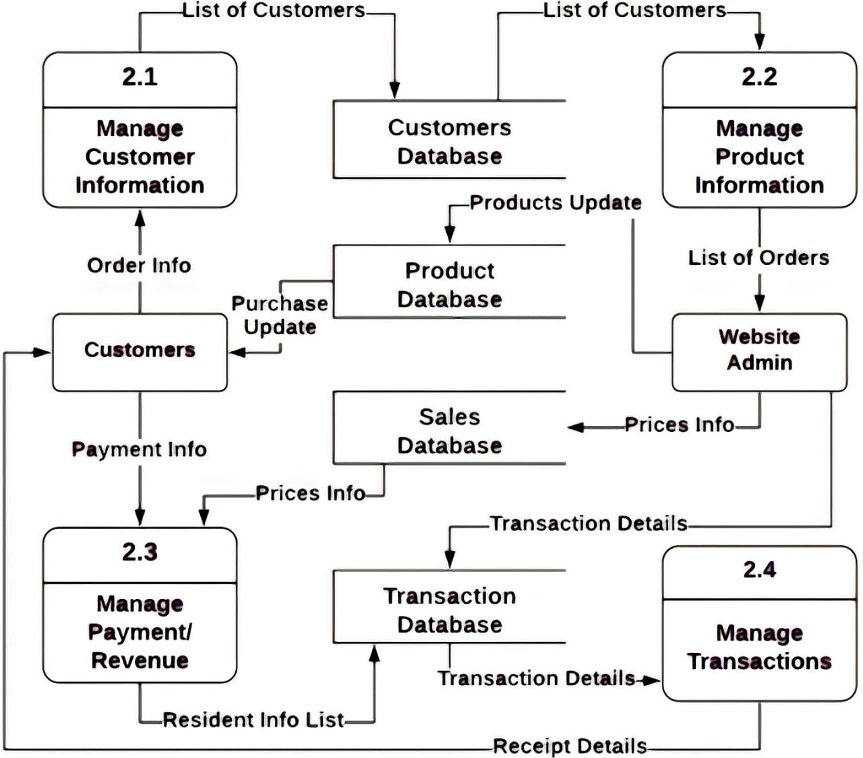

**E R D**

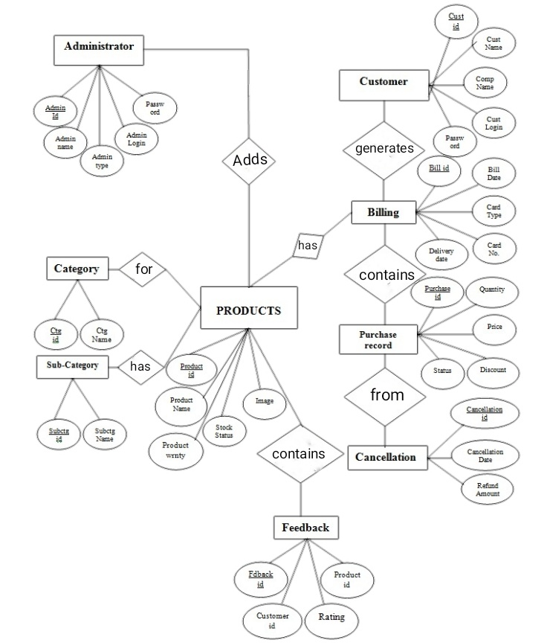



Register as member

Add new product

Staff

Place order

Update product details

Customer

Process rental

<< extend >>

Return product

Give feedback

Reply to customer's

feedback

Admin

View report

## Use-Case Dependency Diagram

Depends on

Register as Member

Add new product

Update product details

Pick product

Process order

<< extend >>

Return product

<< extend >> << extend >>

Reply to customer's

feedback

Late return

Early return

Depends on

Give feedback/

comments

Place order

<<include >>

View customer's

patronage

View report

<< include >>

View transaction

report

## SEQUENCE DIAGRAMS

###### Register as member :



Customer: A

Interface:"reg

001"

Control:c008

Customer

Database

Enter details

Enter username

Check username

Enter password

Read and accept terms

Confirm and Submit

Validate registration

Update database

Send login parameters as email

# Adding a New Products



Login

provide admin page

Enter new product details

Log out

Close session

Add to database

Pass to control

Confirm and submit

Check validity

Pass to control

Database

Control:Admin Handler

New Car page: P001

taff: Subir

# View Report



Login

Check validity

Retrieve report

End session

Log out

Specify report

Database

Report Control: c008

Report page: P002

Admin: prosanta

### Input Output Screenshots

##### Home Page

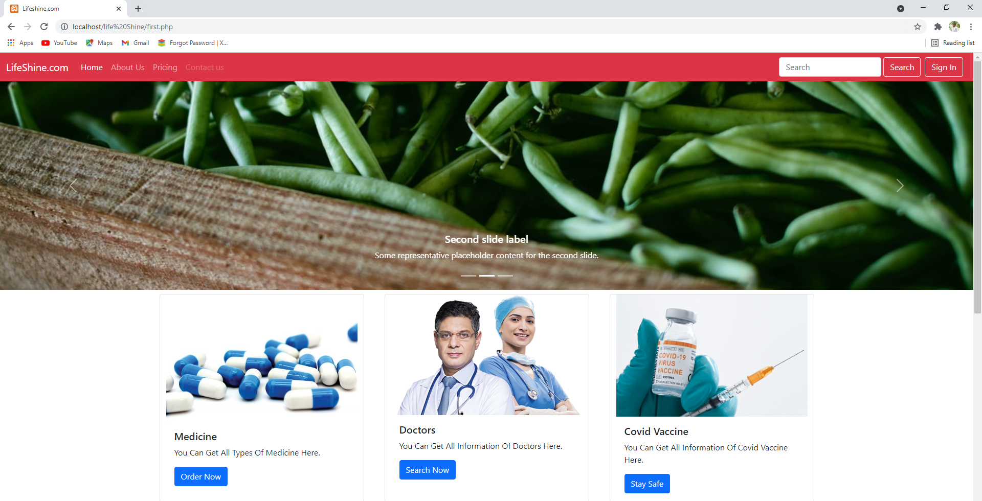

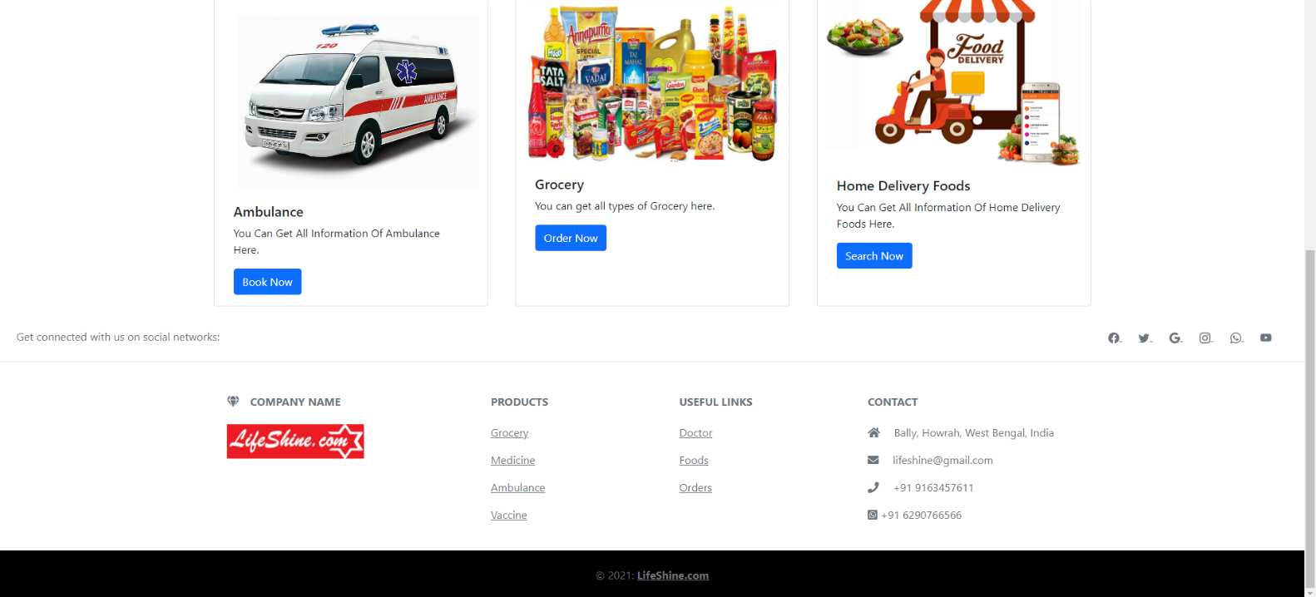

***Customer Sign Up and Log In Page***

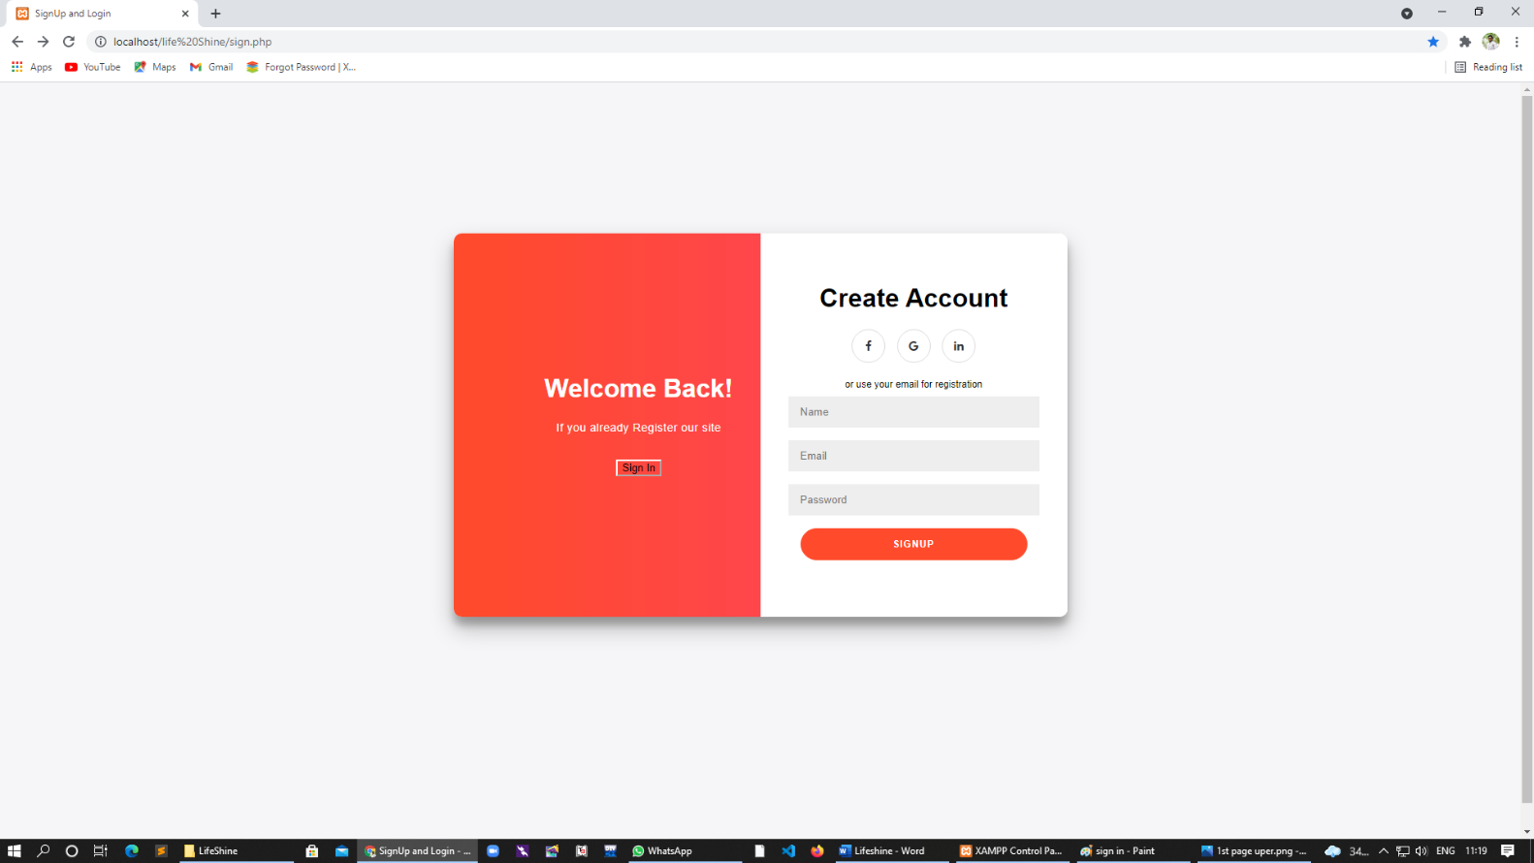

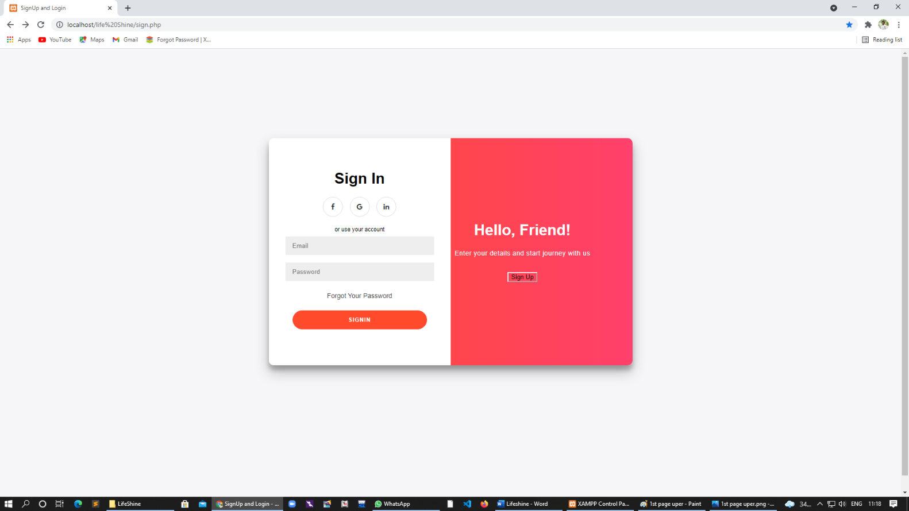

##### Medicine page

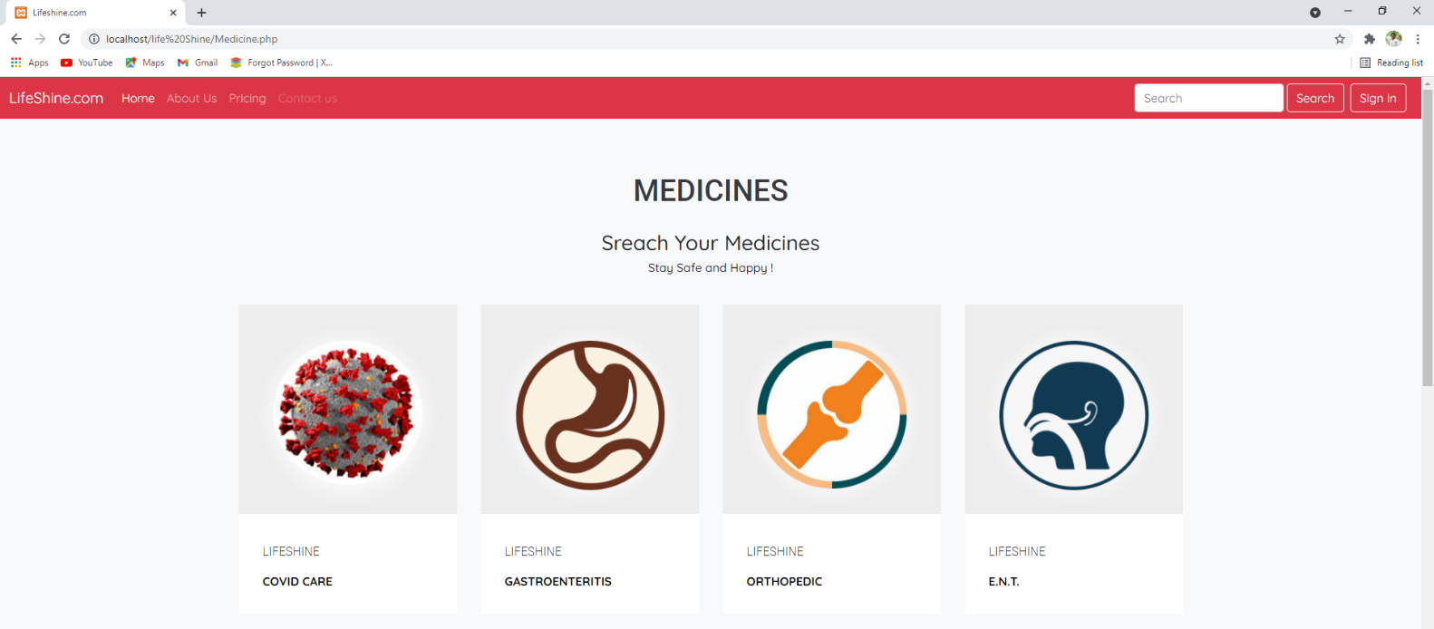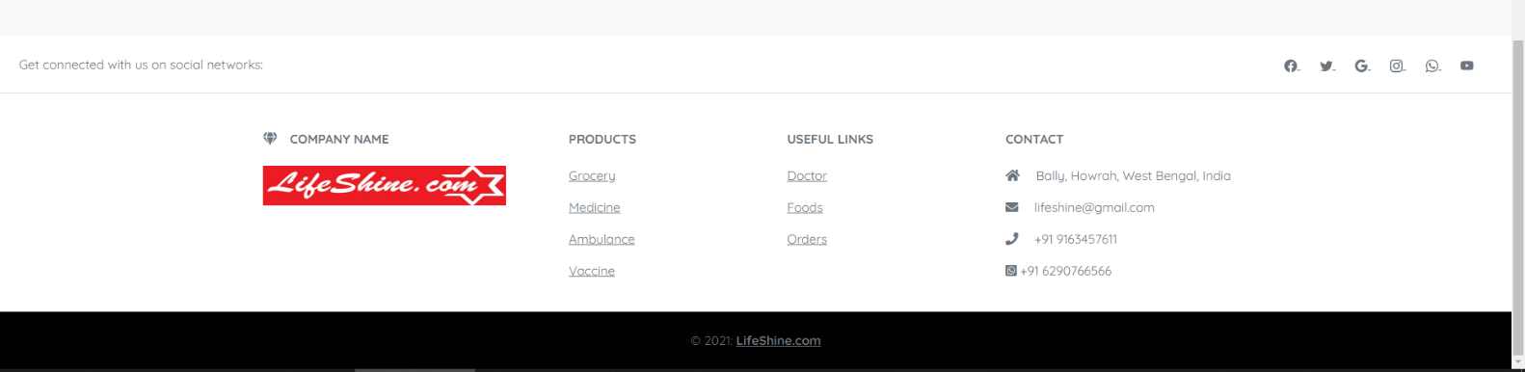

**Medicine Sectors**

**Covid care**

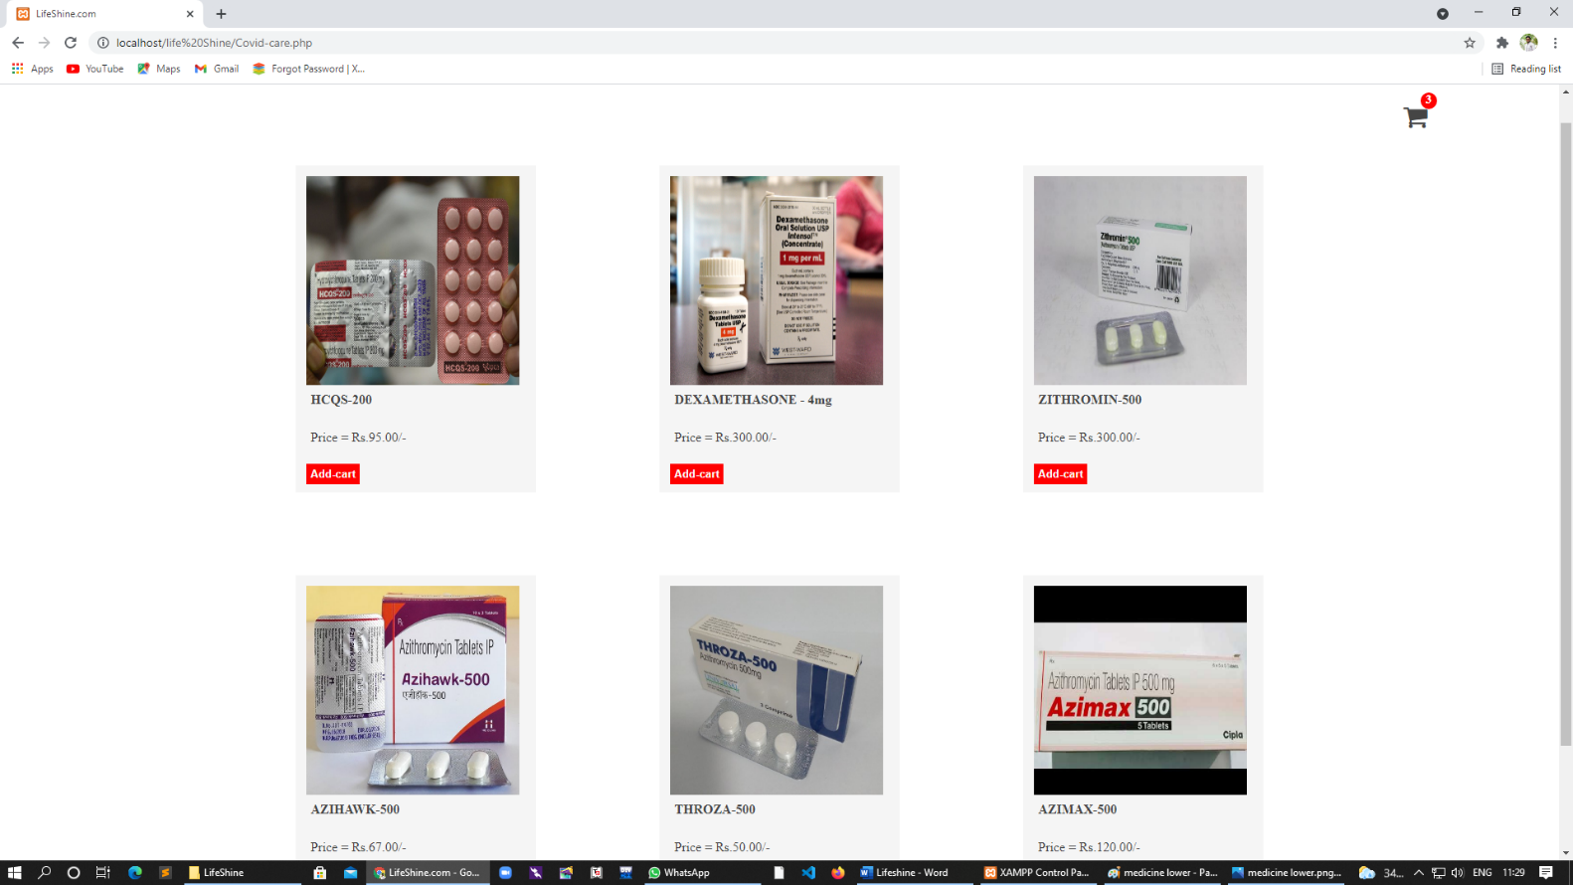

**Gastro**

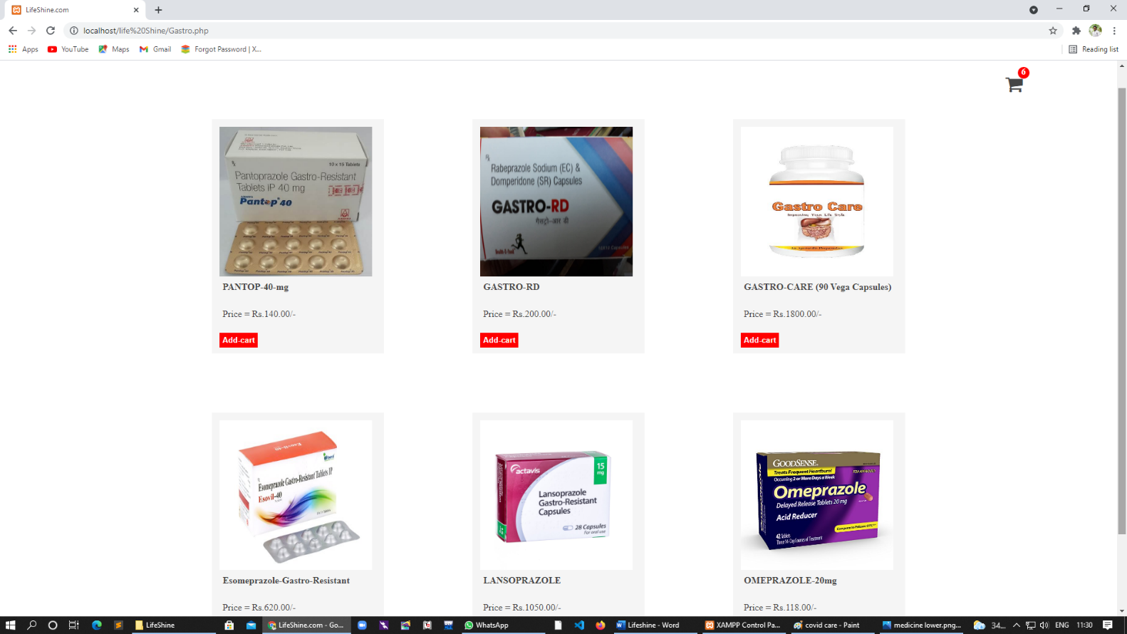

**Orthopedic**

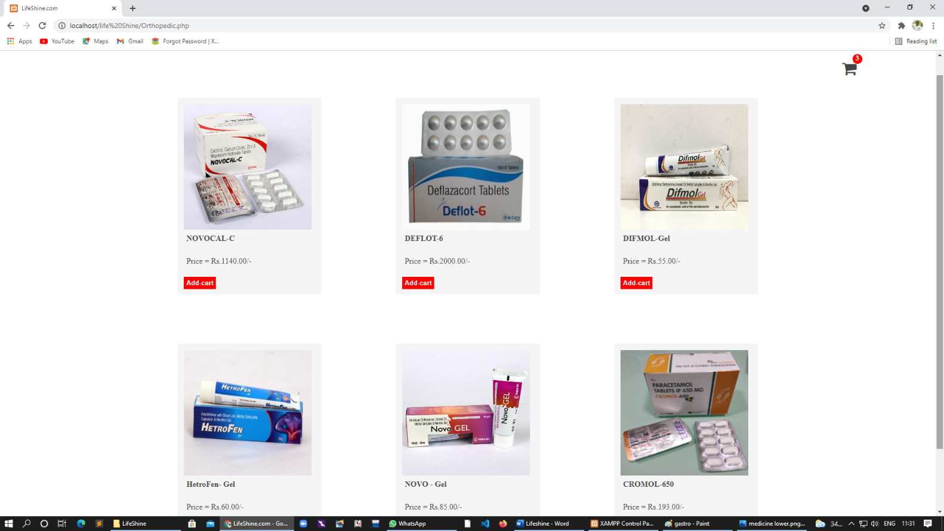

**E.N.T.**

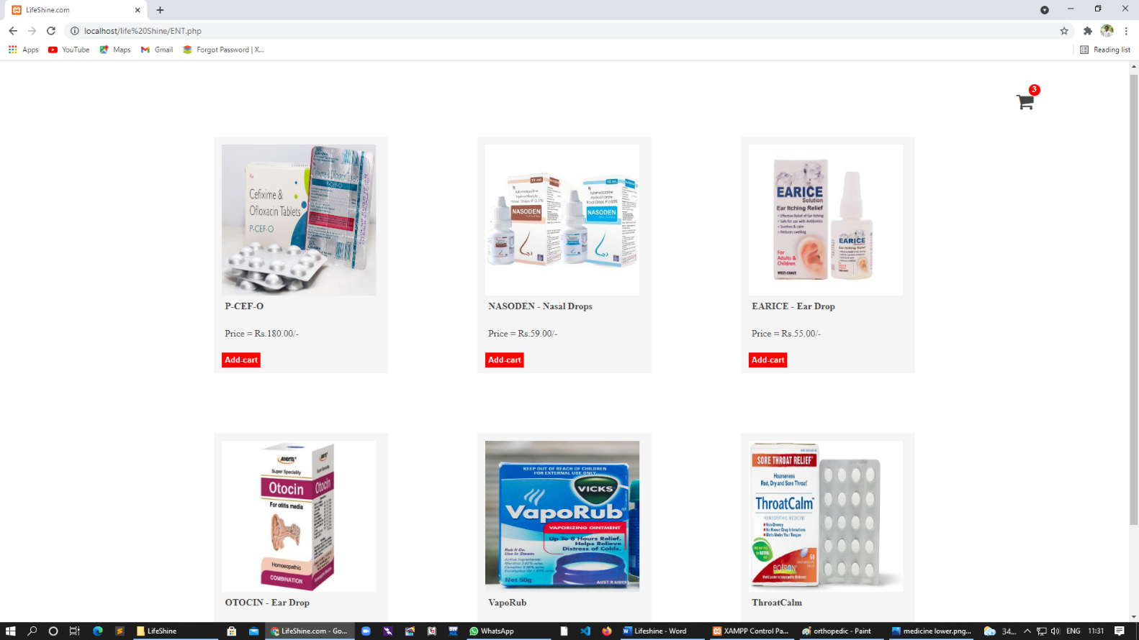

**Urology**

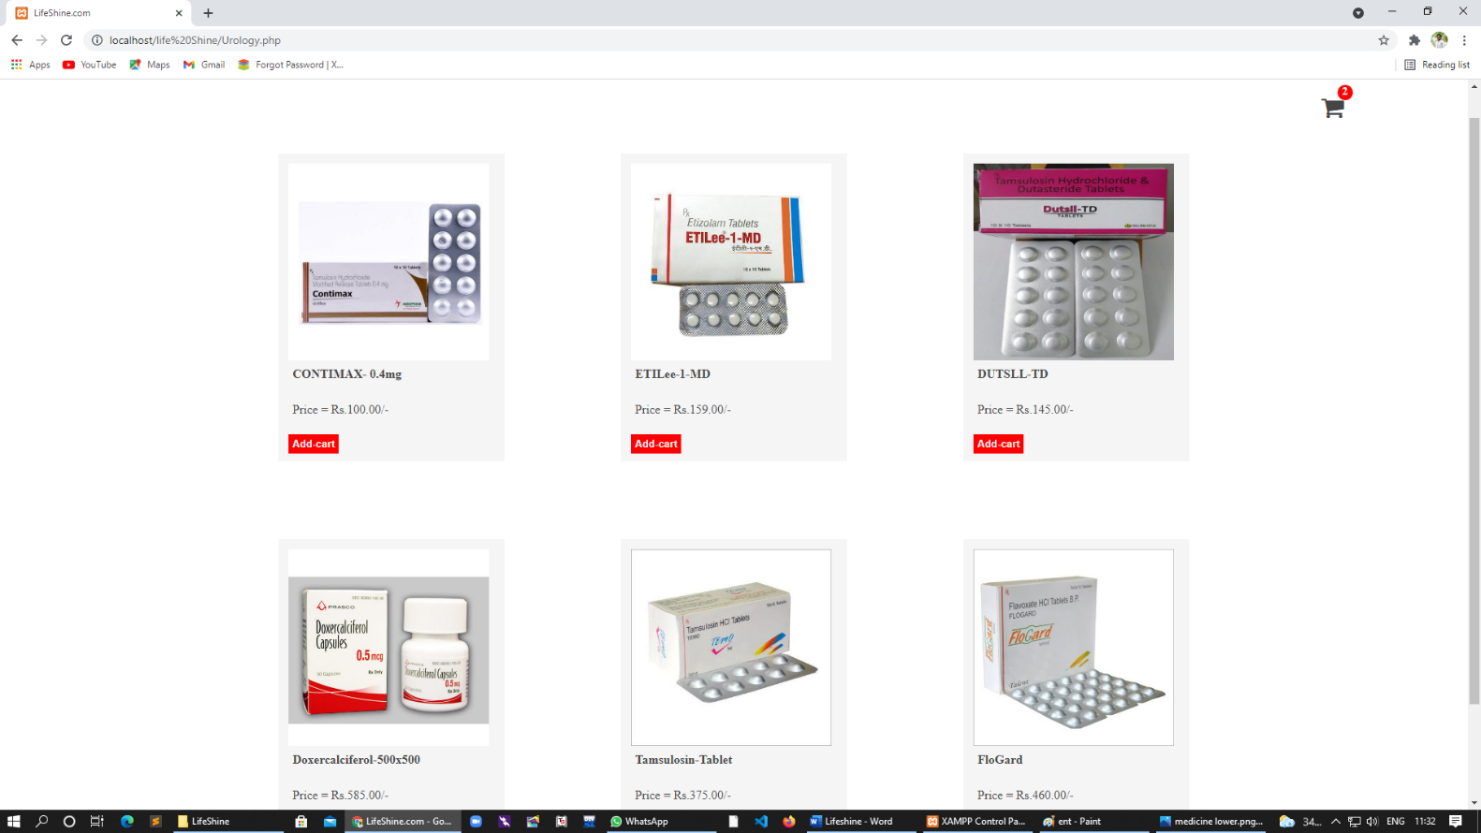

**Chest**

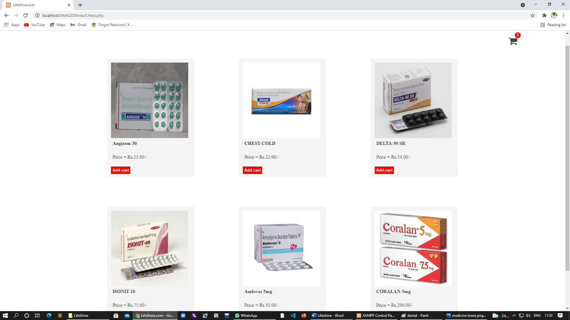

**Dental**

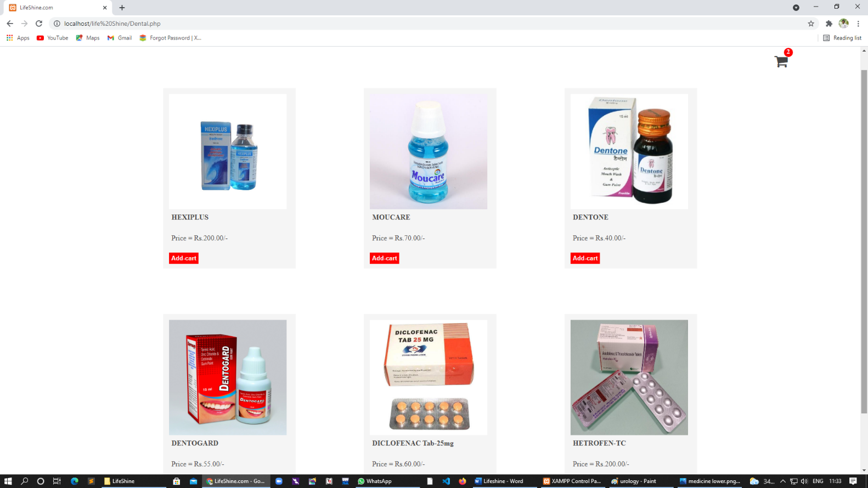

**Cardiology**

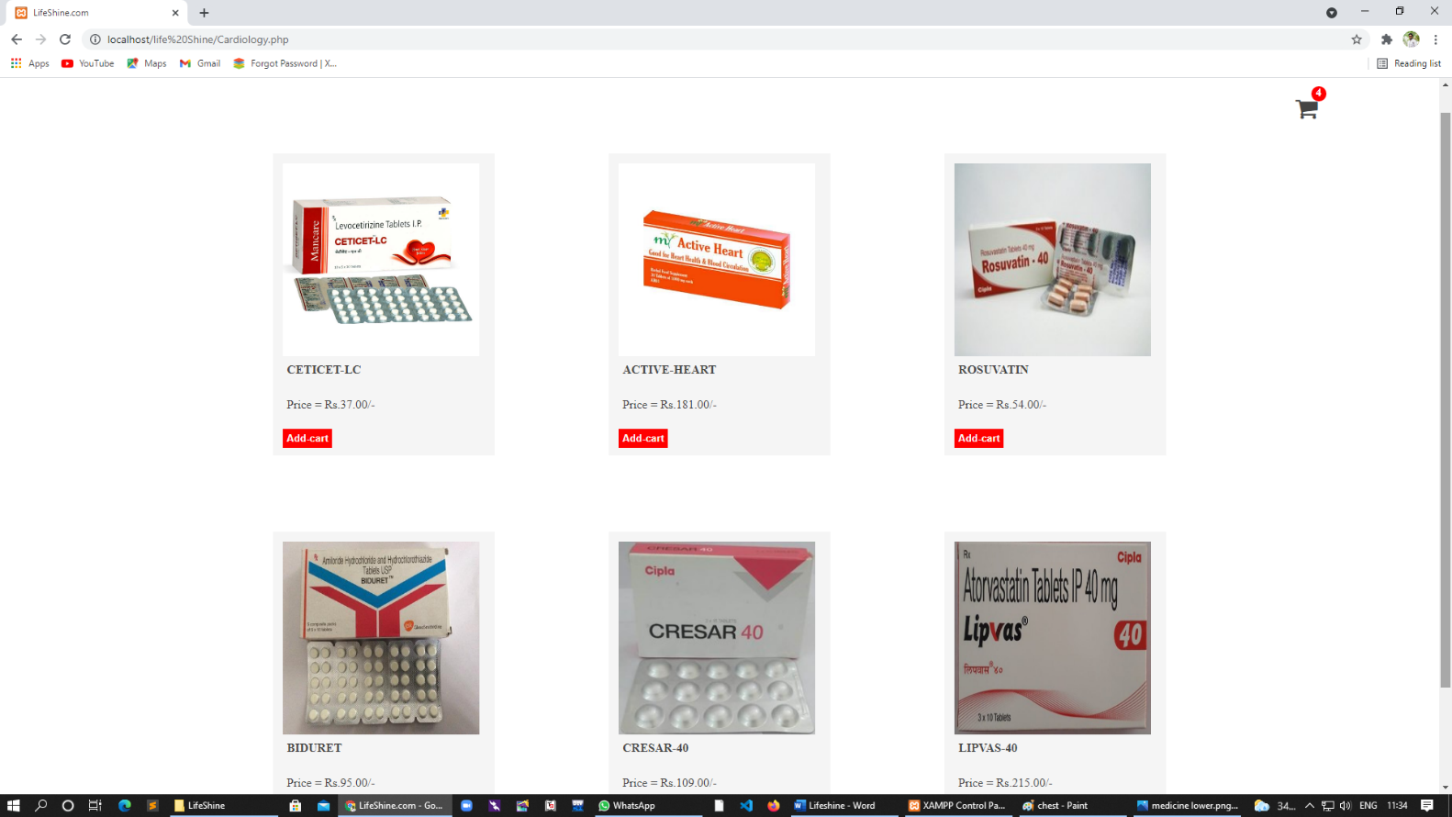

**Child**

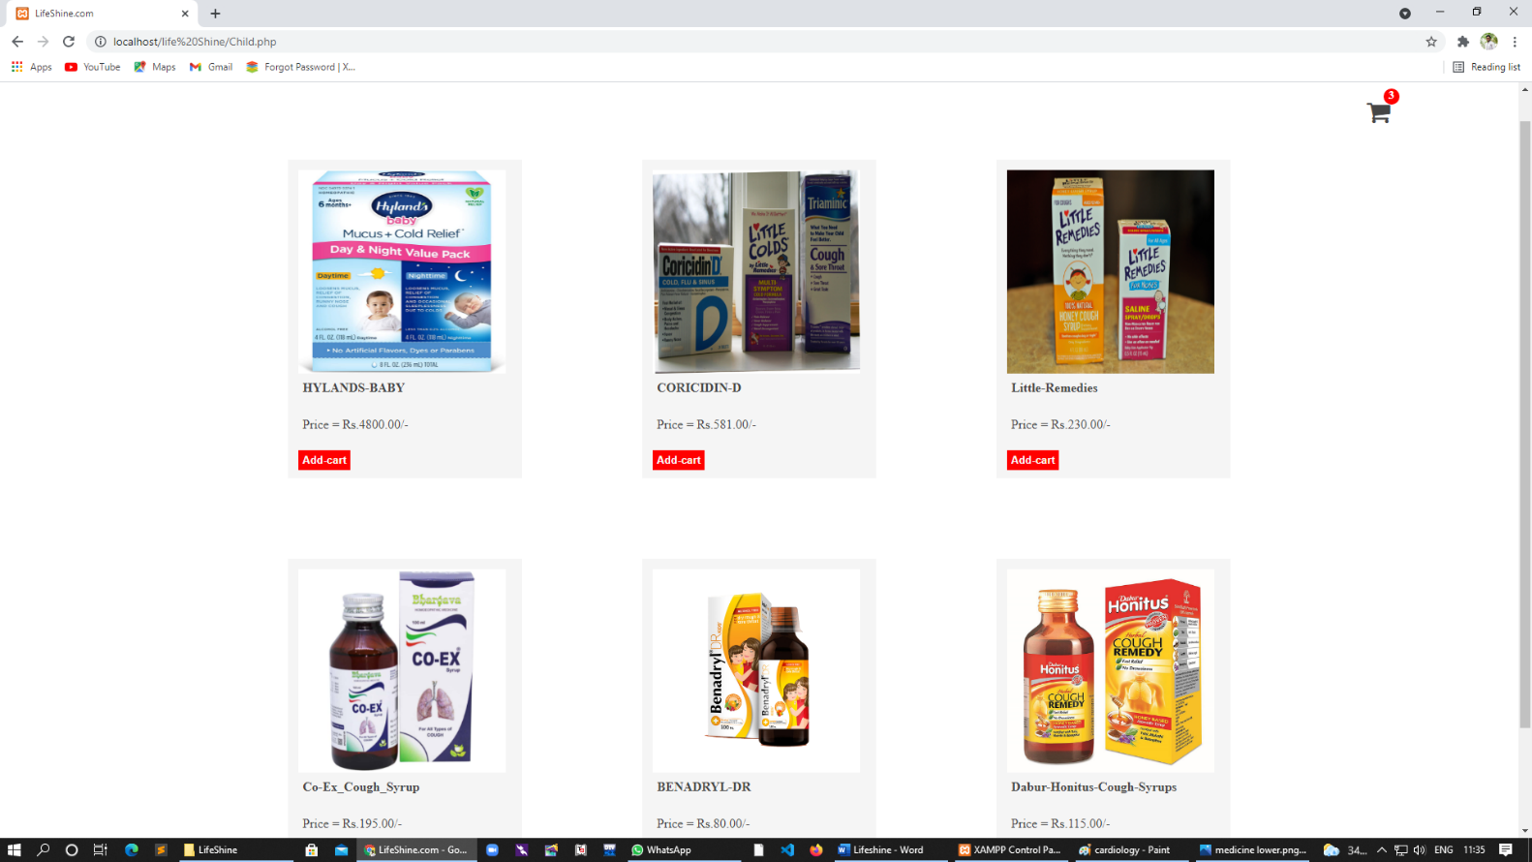

**Skin**

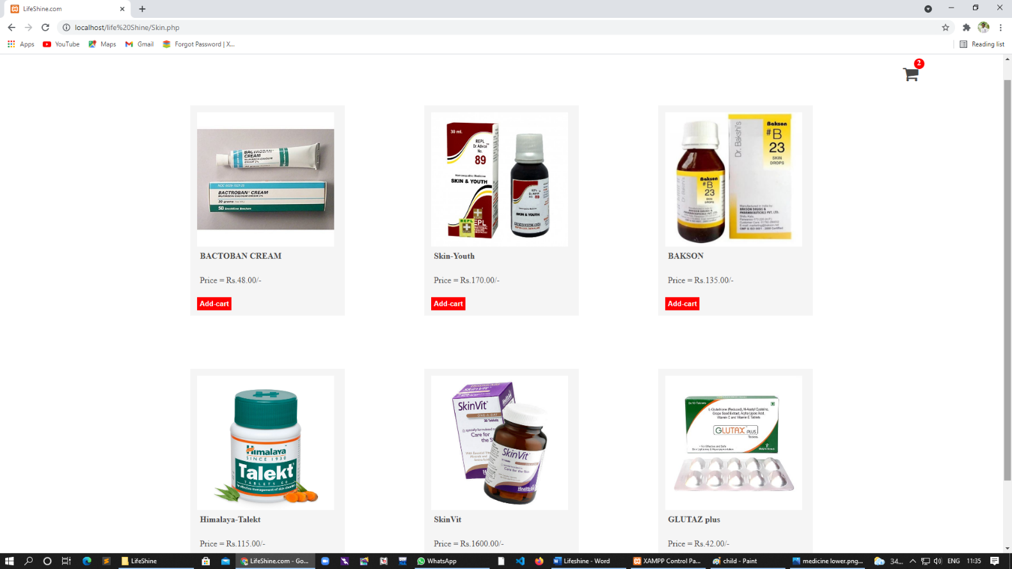

**Eye**

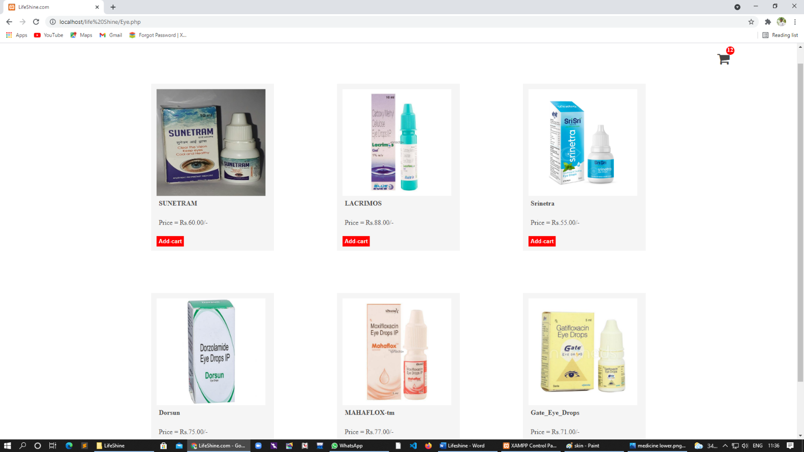

**Demo of Add to Cart**

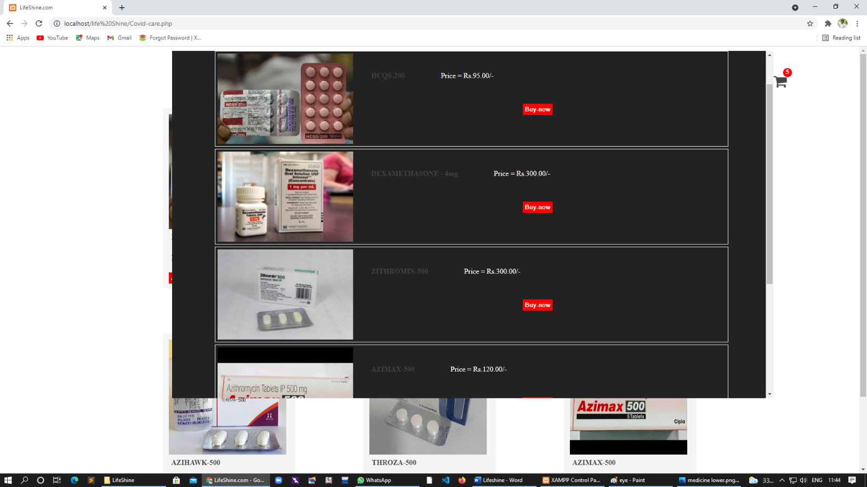

**Doctor page**

##### 





**Doctor Sectors**

**Covid Care Doctors**

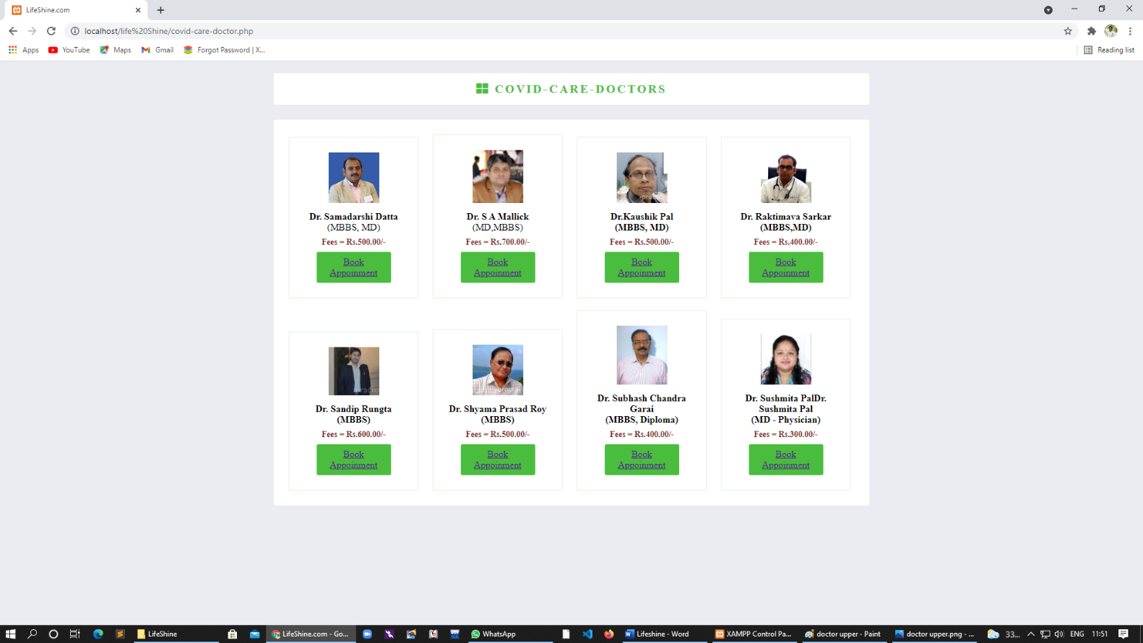

**Gastro Doctors**



**Orthopedic Doctors**

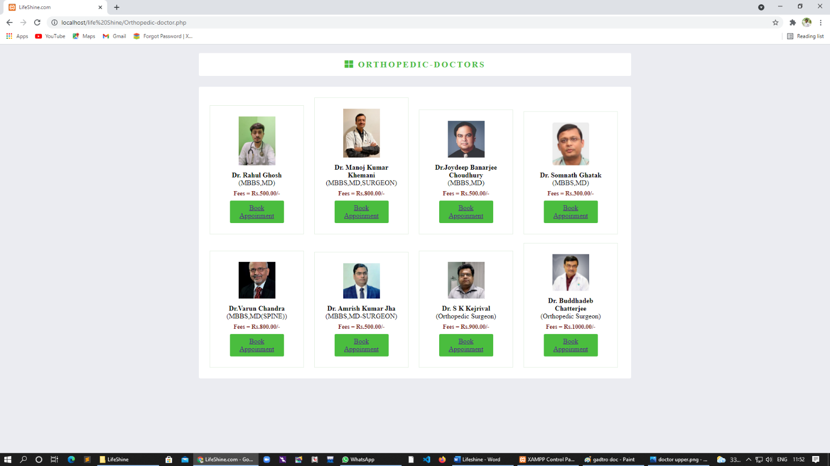

**E.N.T. Doctors**

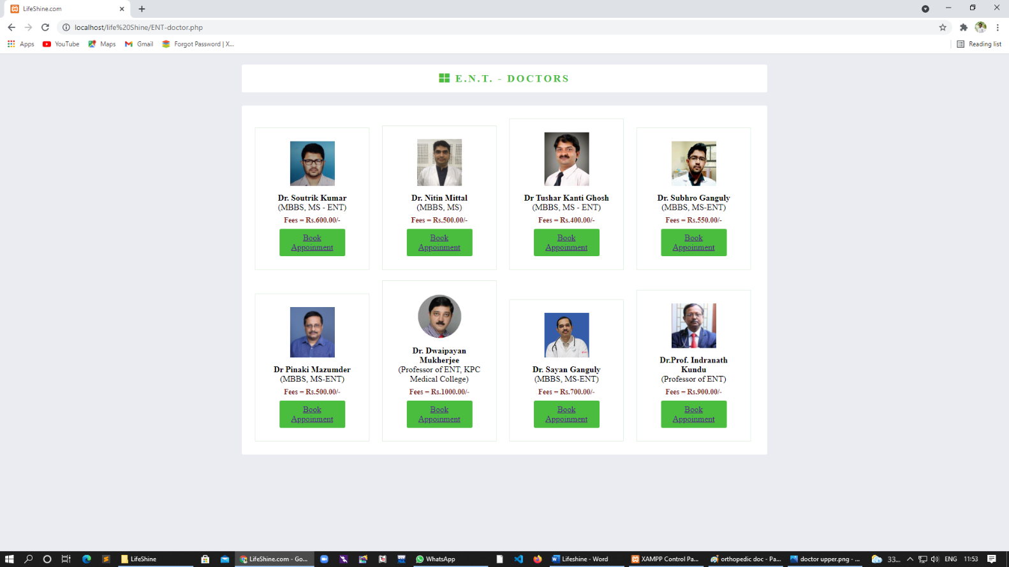

**Urology Doctors**

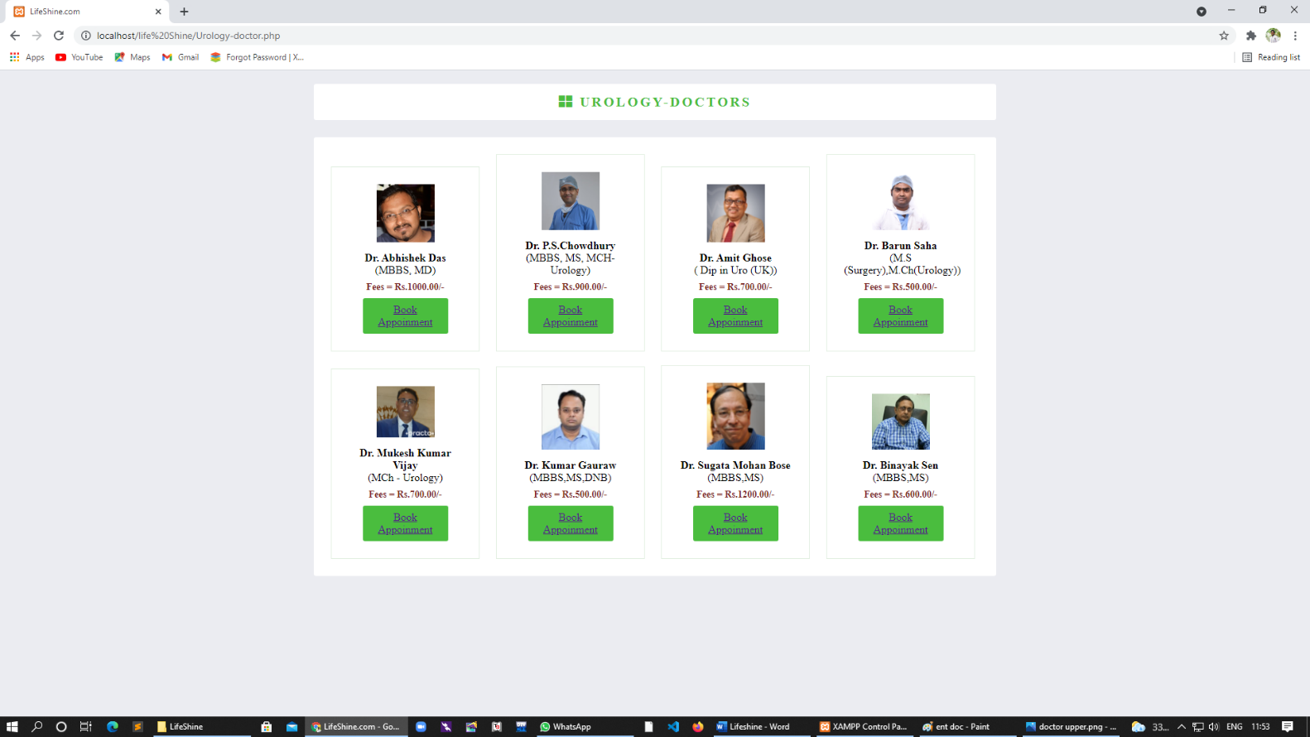

**EYE Doctors**

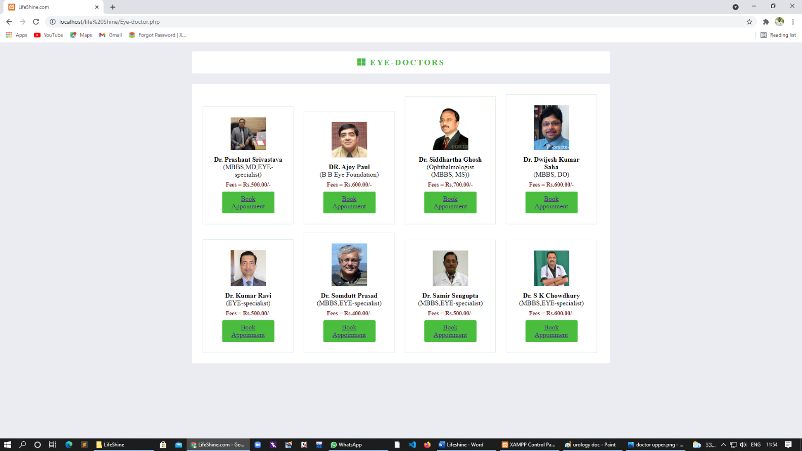

**Vaccine Sectors**

**Vaccine Sector is connected with CO-Win**

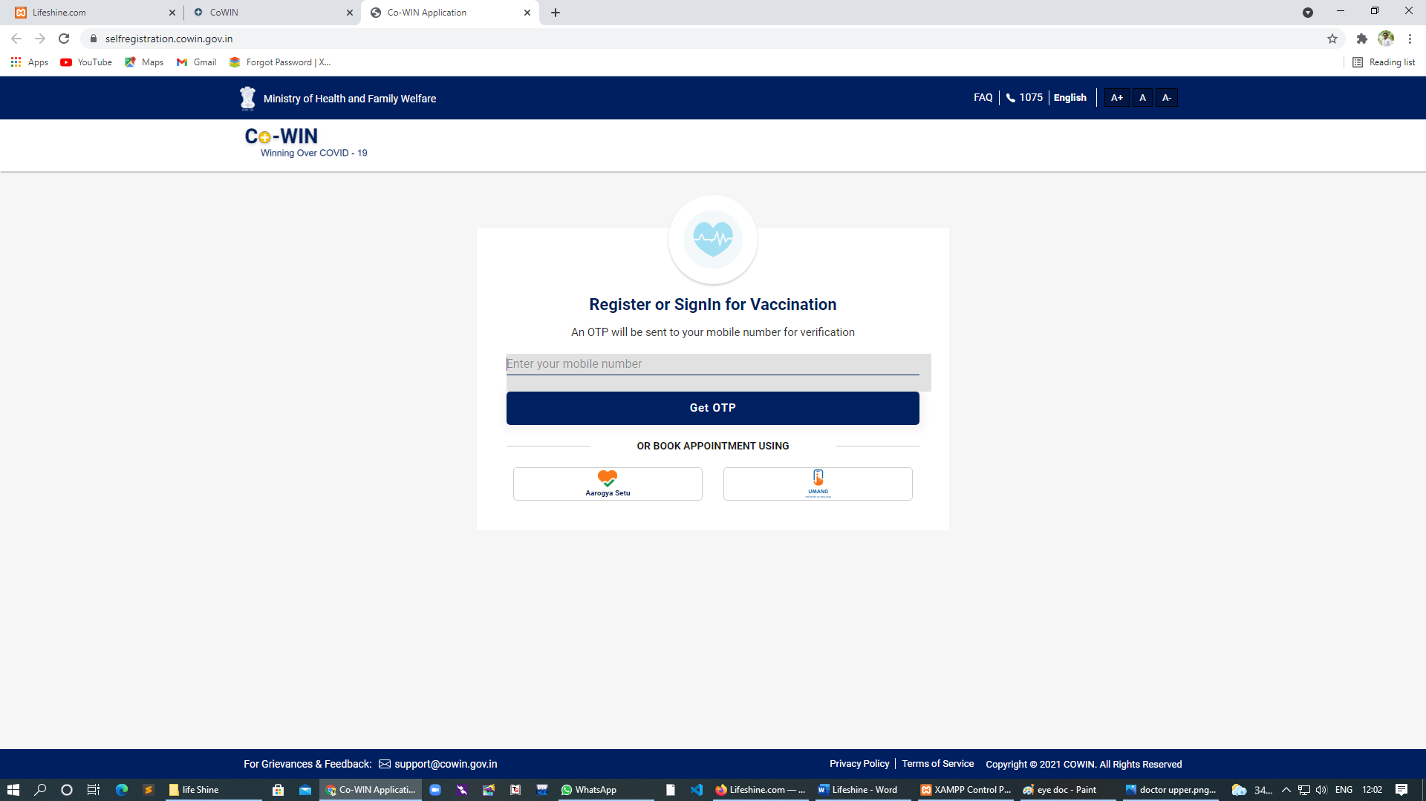

**Grocery Page**

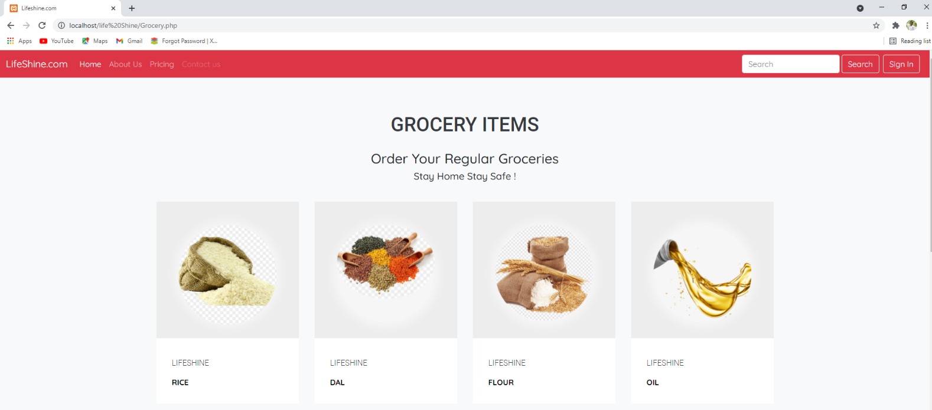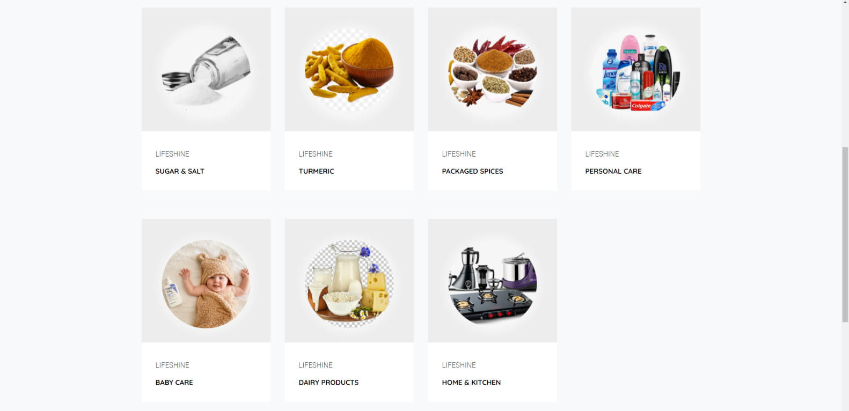



**Grocery Sectors**

**Rice**

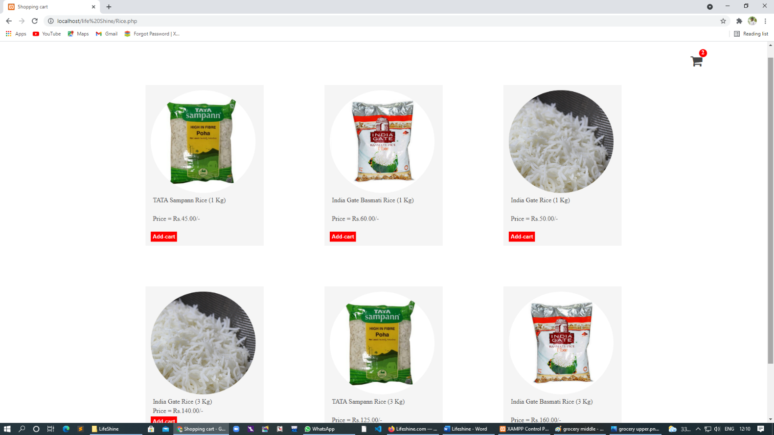

**Dal**

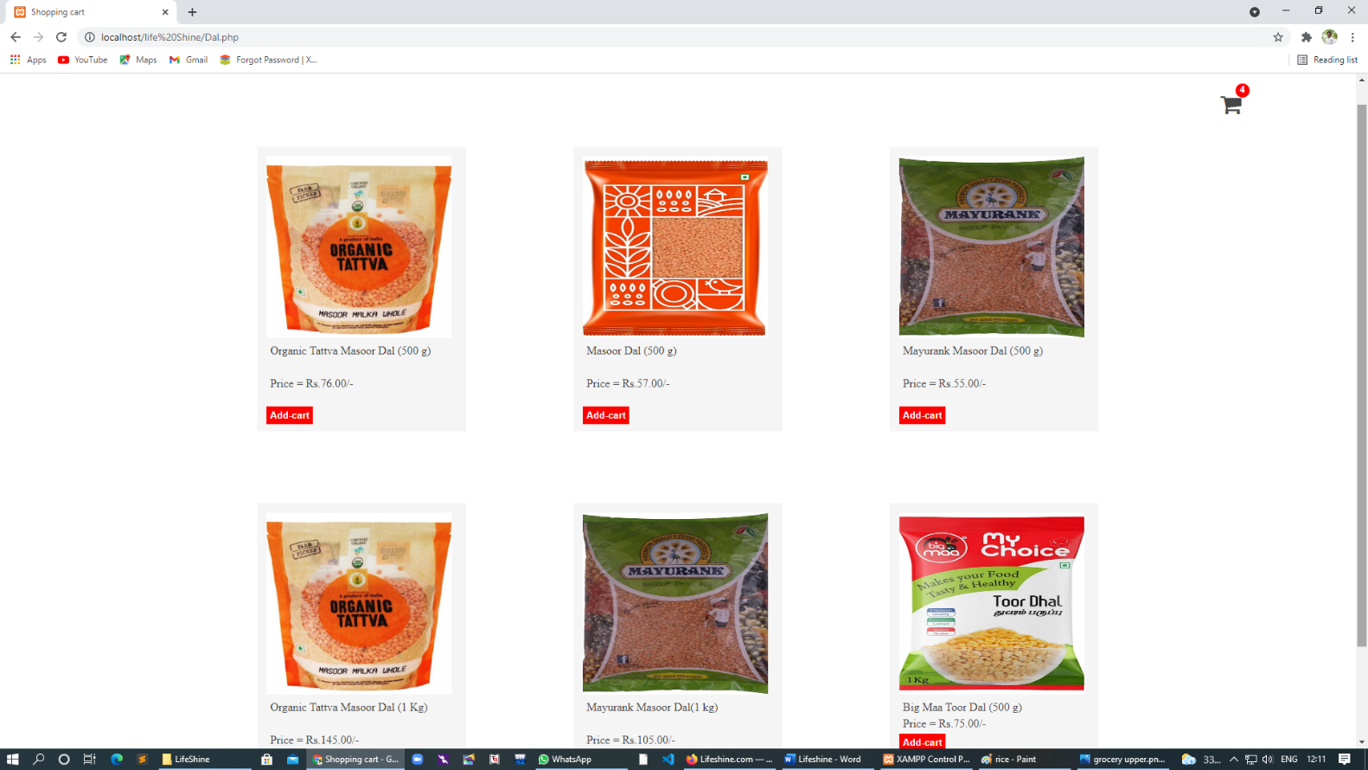

**Flour**

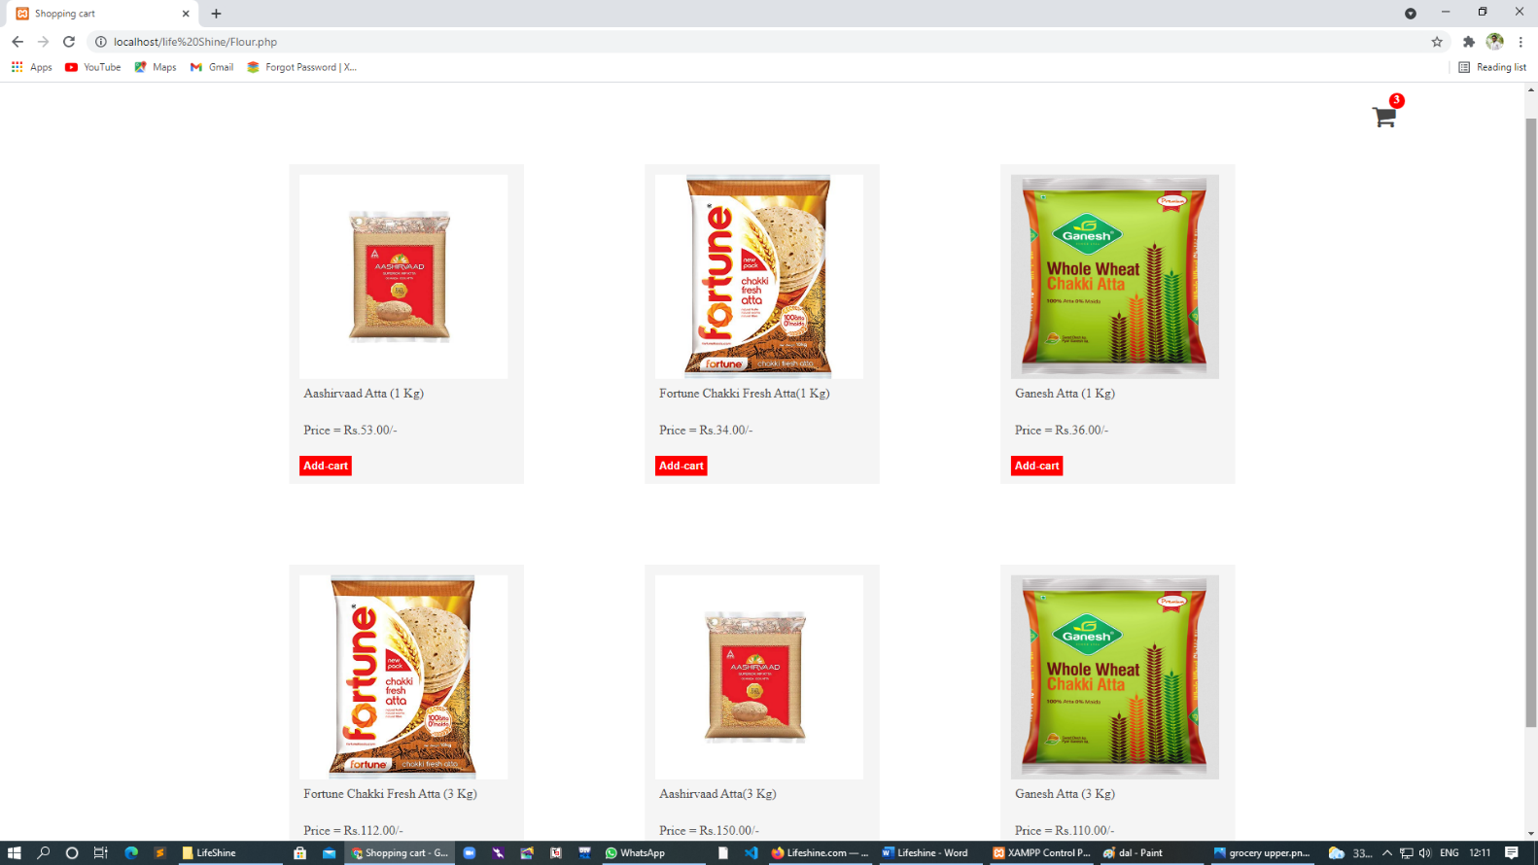

**Oil**

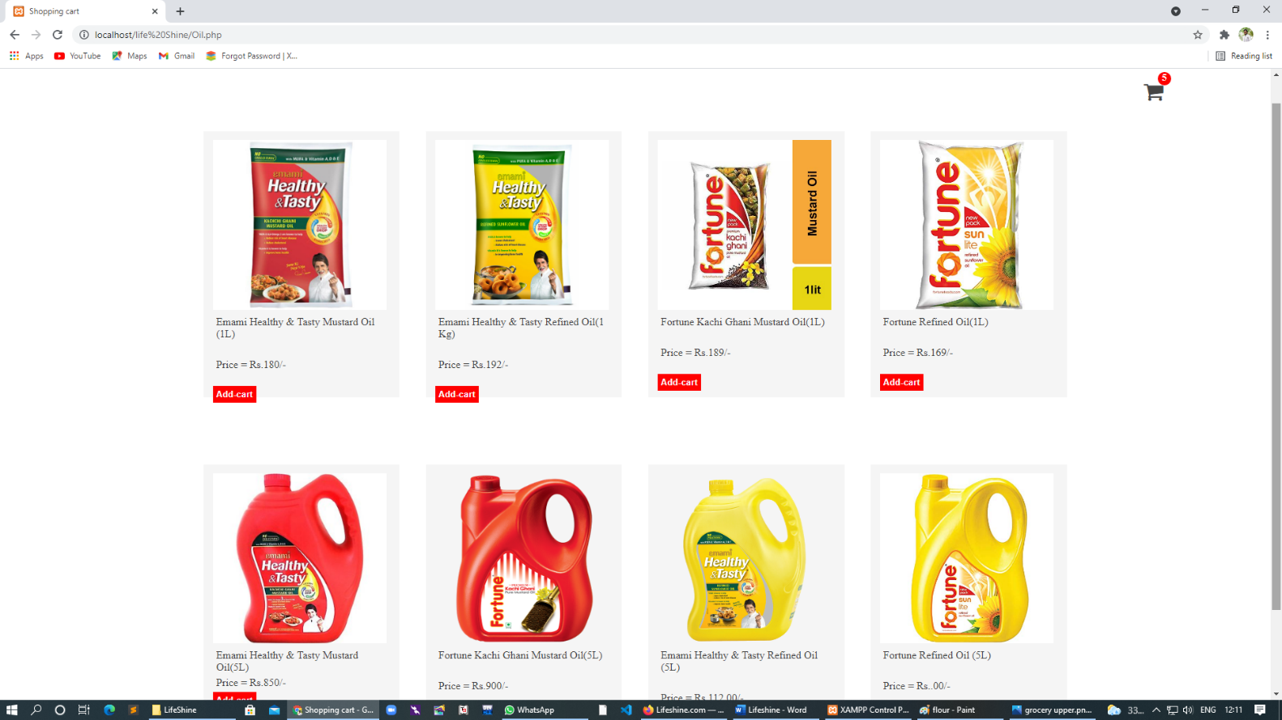

**Sugar & Salt**

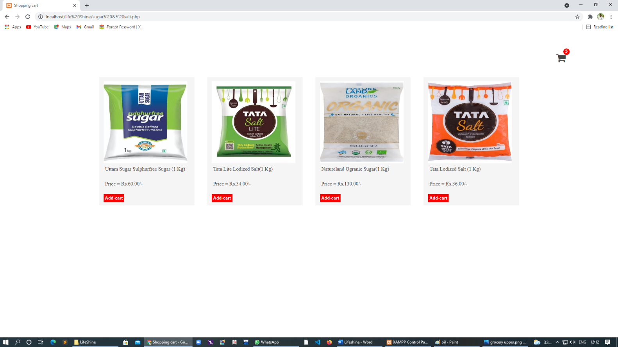

**Turmeric**

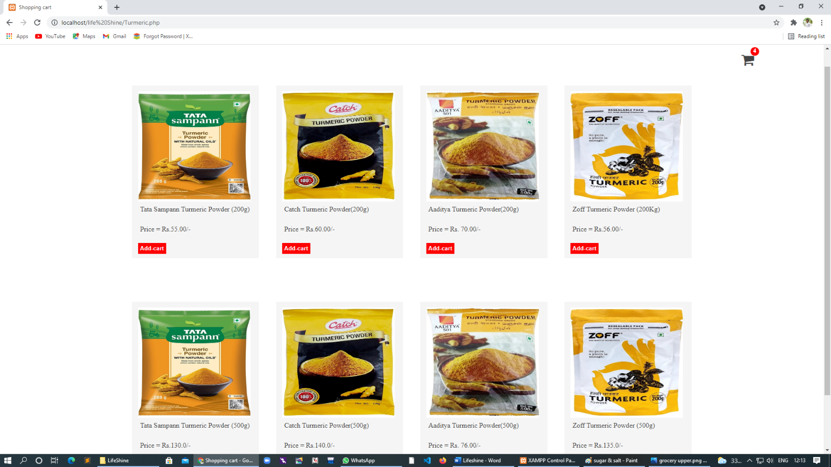

**Personal Care**

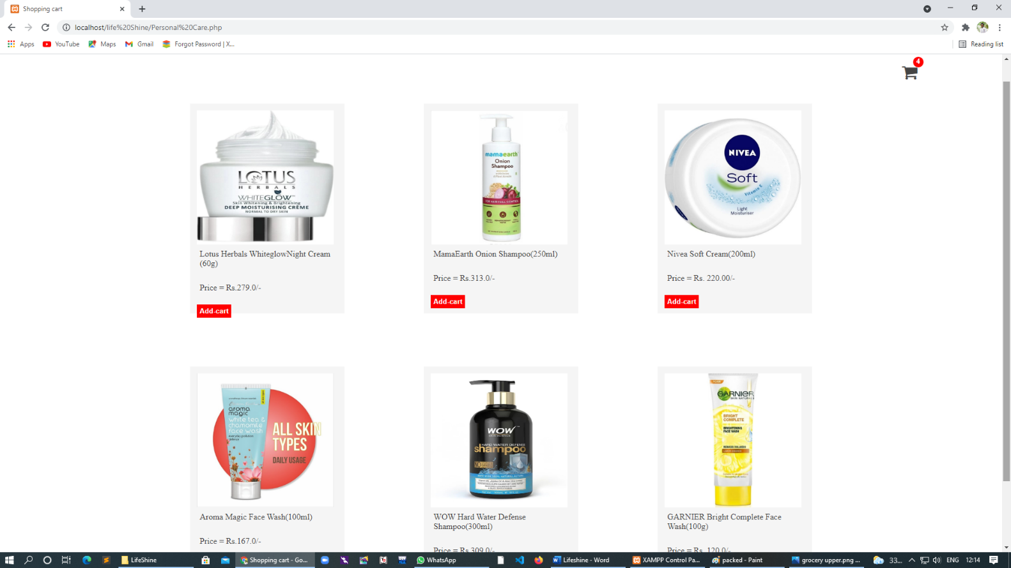

**Baby Products**

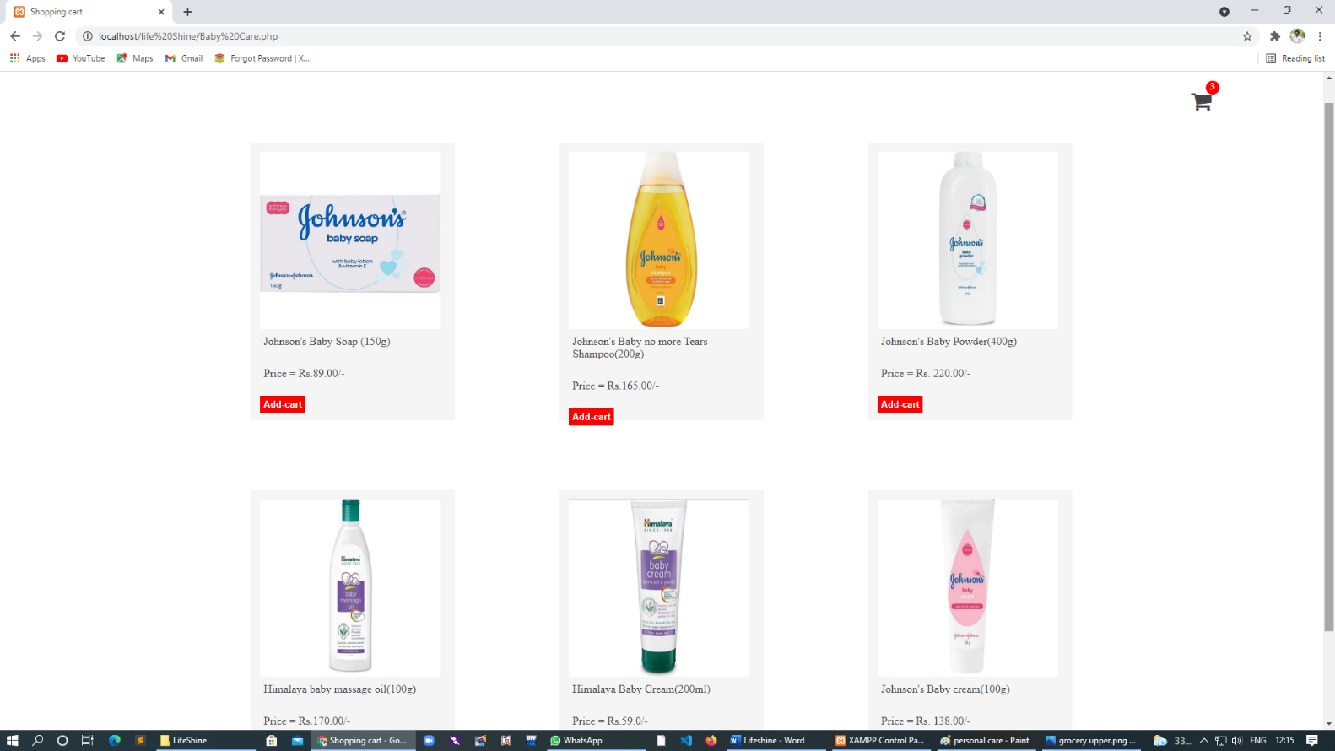

**Dairy Products**

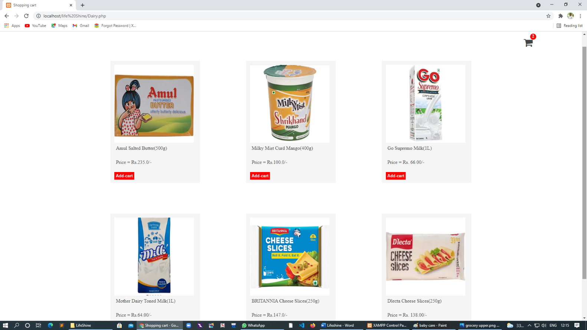

**Home Kitchen**

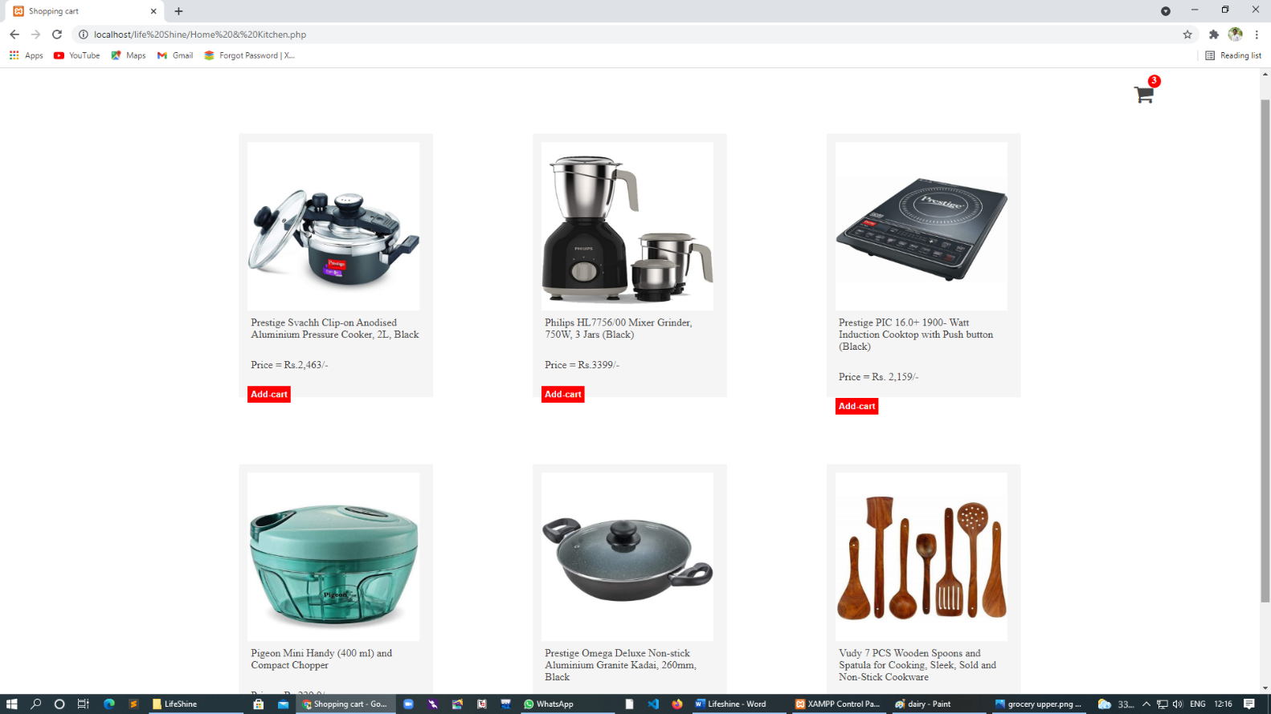

**Place Order**

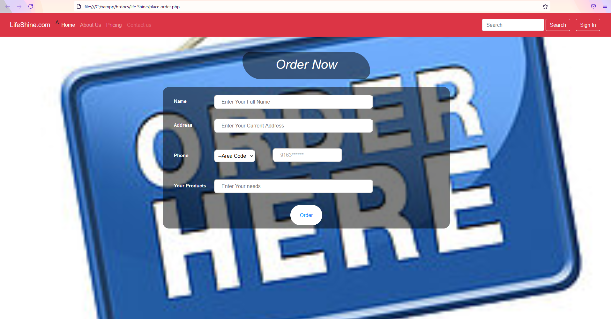

**Database**

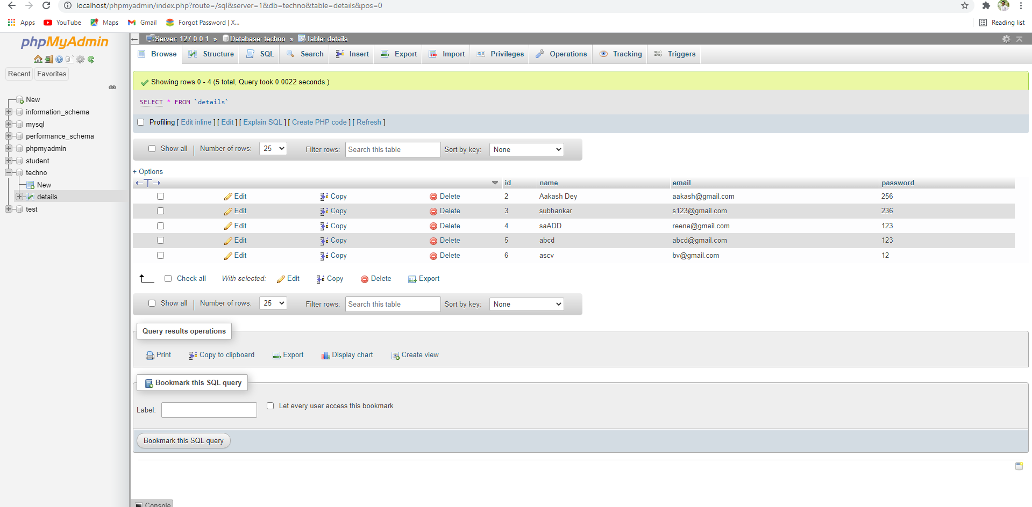

### Methodology used for testing

1. Features to be tested

We will start by using both static and dynamic testing strategies. The static strategies will include reviewing the basics of the application whereas the dynamic testing is based on actual code execution. The features we tested were as follows:

* To ensure that the application itself ran (Dynamic)
* log-ins worked efficiently and consistently (Dynamic)
* accessing the web app from multiple platforms to ensure

cross compatibility (Dynamic)

* checking page load time (Dynamic)

1. Test Cases

The following are examples of test cases we implemented:

* Dropdown fields should have first entry as blank or text like ‘Select’
* Amount values should be displayed with correct currency

symbols

* Graphical User Interface
* All fields on page (e.g. text box, radio options, dropdown lists) should be aligned properly
* Upon click of any input text field, mouse arrow pointer

should get changed to cursor

* Check all pages for broken images • Check all pages for

broken links

1. Testing Schedule

The testing should begin right after the project itself begins. Keeping up on testing will ensure that any mistakes are caught early and corrected immediately.

### Conclusion

In our project Online Grocery and Medicine order System we used Html, Css, Bootstrap JavaScript (The Front-end Application) With MySQL as Back end database storage and our scripting Language is PHP(Hypertext Preprocessor).

Throughout this project we tried to give it a professional realistic look and feel with our knowledge and understand ability about an Online Grocery and Medicine order System. It is a small effort towards a small venture.

### BIBLIOGRAPHY

To complete this project successfully, we consulted with our project guide took the help of the following books and websites.

***Sites***

* 1. [http://www.google.com](http://www.google.com/)
  2. [http://www.w3schools.com](http://www.w3schools.com/)
  3. [http://www.php.net](http://www.php.net/)
  4. [http://www.homeandlearn.co.uk](http://www.homeandlearn.co.uk/)

***Books***

1. BeginningPHP5
2. Internet Notes, etc.

